Analyzing the impact of Macmillan’s new models

In response to the negative feedback from libraries on the embargo purchase model, Macmillan has proposed three new eLending models. This document will analyze what the new models would cost the Washington Digital Library Consortium if Macmillan were to institute one of the models and we were to purchase a variety of new titles similar to the Macmillan titles we purchased around this time last year.
The titles represent a range of books:
- Black and Blue, the 3rd entry in a moderately popular mystery series
- The First Conspiracy, an adult nonfiction book
- King of Scars, a fantasy young adult novel
- The Remarkable Journey of Coyote Sunrise, a juvenile fiction book
- The Silent Patient, a best-selling thriller

New models
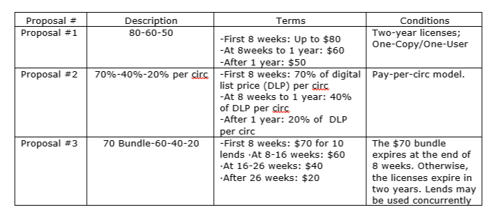

High level summary:
Title | Actual | Prop. #1 | % inc. | Prop. #2 (low) | % inc. | Prop. #2 (high) | % inc. | Prop. #3 | % inc.
Black and Blue | $120.00 | $160.00 | 33% | $370.74 | 209% | $715.24 | 496% | $400.00 | 233%
The First Conspiracy | $120.00 | $240.00 | 100% | $374.63 | 212% | $674.63 | 462% | $520.00 | 333%
King of Scars | $160.00 | $320.00 | 100% | $468.53 | 193% | $937.53 | 486% | $710.00 | 344%
The Remarkable Journey of Coyote Sunrise | $160.00 | $260.00 | 63% | $391.61 | 145% | $666.01 | 316% | $490.00 | 206%
The Silent Patient | $680.00 | $1,340.00 | 97% | $3,305.84 | 386% | $4,489.70 | 560% | $2,710.00 | 299%
Average % increase |  |  | 79% |  | 229% |  | 464% |  | 283%

Price:
While some of the models include a decrease in prices after a certain time, in practice, we would rarely be able to take advantage of that assuming we continue to deliver the same level of service to patrons that we currently maintain. We do the bulk of our buying in the first 8 weeks, which is the time period on which Macmillan has set a premium, so in practice, the new models will cost us at least 80% more for the same kinds of books at the same license models.
The third proposal does offer simultaneous use, for which we would be willing to pay more, but not 280% more.
Access:
This analysis assumes that the consortium would continue to offer the same level of access we offer now. However, in practice, significant price increases would mean that we would have to buy fewer books.
Collection maintenance cost:
Multiple selectors have provided the feedback that picking and choosing when to purchase books based on their release date is not something they do now, so would be added work. Similarly, the eLending platforms do not the robust reporting we would need to stay ahead of expiring bundles, so customer service is likely to decrease.
It is also worth noting that every new model requires software implementation and maintenance. As the eLending platform customers, these costs are passed along to us.

Black and Blue: Doug Brock Series, Book 3, by Doug Rosenfelt

Audience: Adult Fiction
Street date: 3/26/2019
Circulation between 1/1/2019 – 3/4/2019: 64
Actual spending
In order to compare the new models to the existing one, we need to establish a baseline and document what we spent under the old metered access model.
Price per copy | $60.00
Copies purchased | 2
Total spent | $120.00

Proposal #1: $80 in weeks 1-8, $60 in weeks 9-52, $50 thereafter

We purchased both of our copies in the first 8 weeks.
Street date | 3/26/2019

Purchase dates | Weeks after street date
4/30/2019 | 5
5/7/2019 | 6

 | Cost per copy | Copies purchased | Total cost
Weeks 1 - 8 | $80.00 | 2 | $160.00
Weeks 9 - 52 | $60.00 | 0 | $0.00
> 52 | $50.00 | 0 | $0.00
 |  | Total | $160.00
 |  | Previous total | $120.00
 |  | % change | 33%

Summary: proposal #1 would cost us 33% more to provide the same level of service.

Proposal #2: pay-per-circ indexed to digital list price

Searching on Kindle shows two list prices, so we will run numbers for both and provide high and low estimates. The list price we would be expected to conform to is likely to be higher than the list price now since these books have been out for a year.
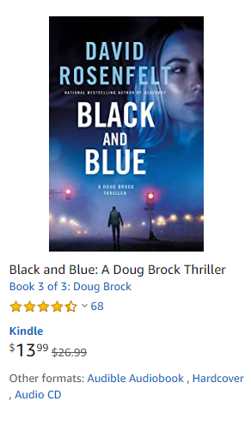

Low estimate

 | 100% | 70% | 40% | 20%
Digital list | $13.99 | $9.79 | $5.60 | $2.80
 | Circs | Cost per circ | Total
Weeks 1 - 8 | 3 | $9.79 | $29.38
Weeks 9 - 52 | 61 | $5.60 | $341.36
> 52 weeks | 0 | $2.80 | $0.00
 |  | Total | $370.74
 |  | Previous total | $120.00
 |  | % change | 209%

Summary: Under this model, we would spend a total of $370.97, a price increase of 209% in order to provide the same level of service.

High estimate

 | 100% | 70% | 40% | 20%
Digital list | $26.99 | $18.89 | $10.80 | $5.40

 | Circs | Cost per circ | Total
Weeks 1 - 8 | 3 | $18.89 | $56.68
Weeks 9 - 52 | 61 | $10.80 | $658.56
> 52 weeks | 0 | $5.40 | $0.00
 |  | Total | $715.24
 |  | Previous total | $120.00
 |  | % change | 496%

Summary: Under this model, we would spend a total of $715.24, a price increase of 496% in order to provide the same level of service.

Proposal #3: bundles of checkouts

 | Est. demand | Bundle cost per 10 SU circs | Bundles required | Total
Weeks 1 - 8 | 20 | $70.00 | 2 | $140.00
Weeks 9 - 16 | 22 | $60.00 | 3 | $180.00
Weeks 17 - 26 | 22 | $40.00 | 2 | $80.00
> 26 weeks | 0 | $20.00 | 0 | $0.00
 |  |  | Total | $400.00
 |  |  | Previous total | $120.00
 |  |  | % change | 233%

Summary: Under this model, we would spend $400.00, a price increase of 233%. This model does provide a better level of service than the OC/OU models, however.
Details on this estimate
This is tricky to model, because the bundles are simultaneous use circs. We have to know what “demand” there was for a book in the weeks after publication in order to guess how many bundles we would need to buy in the different time frames.
As such, this is the estimate in which I have the least confidence. I am attempting to use my consortium’s purchase history to determine the minimum number of readers who would either have an item checked out or would place a request in a given time period. Since I am using a minimum number, it is likely that the estimates are low, because I am “by default” putting demand that can’t be categorized in the lower priced brackets.
With that said, here is the thought process.
We don’t have request history, but we do know that there were requests on B&B because we bought an added copy.
Our holds ratio is 7:1, so we can assume that there were at least 14 people who wanted to read the book at the time we purchased the second copy and maybe up to 20. Let’s split the difference and assume that there were 17 requests in addition to the three people who checked out in the first 8 weeks, for a total of 20.
Let’s also assume that the rest of the demand would spread out evenly between weeks 9-16 and after week 17.
Note: The other factor that makes this a low estimate is that it doesn’t and can’t account for the readers under the OC/OU model who chose to read something else rather than wait for the book, but who, with simultaneous use, would go ahead and check out increasing costs.

The First Conspiracy: The Secret Plot to Kill George Washington by Brad Meltzer

Audience: Adult Nonfiction
Street date: 1/8/2019:
Circulation between 1/1/2019 – 3/4/2019: 92
Actual spending
Price per copy | $40.00
Copies purchased | 3
Total spent | $120.00

Proposal #1: $80 in weeks 1-8, $60 in weeks 9-52, $50 thereafter

Street date | 1/8/2019

Purchase dates | Weeks after street date
1/21/2019 | 2
1/29/2019 | 3
2/12/2019 | 5

 | Cost per copy | Copies purchased | Total cost
Weeks 1 - 8 | $80.00 | 3 | $240.00
Weeks 9 - 52 | $60.00 | 0 | $0.00
> 52 | $50.00 | 0 | $0.00
 |  | Total | $240.00
 |  | Previous total | $120.00
 |  | % change | 100%

Summary: under this model, we will pay double (100% increase) what we paid a year ago for the same level of service for our patrons.

Proposal #2: pay-per-circ indexed to digital list price

Here are the numbers we will be using for our low and high estimates
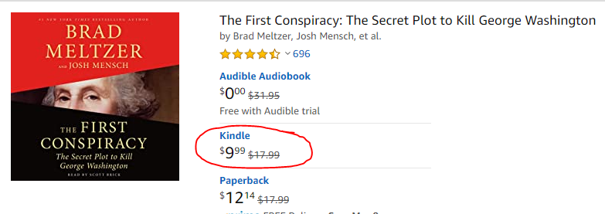

Low estimate

 | 100% | 70% | 40% | 20%
Digital list | $9.99 | $6.99 | $4.00 | $2.00

 | Circs | Cost per circ | Total
Weeks 1 - 8 | 11 | $6.99 | $76.92
Weeks 9 - 52 | 68 | $4.00 | $271.73
> 52 weeks | 13 | $2.00 | $25.97
 |  | Total | $374.63
 |  | Previous total | $120.00
 |  | % change | 212%

Summary: this model would require us to pay 212% over what we paid last year to provide the same level of service.

High estimate

 | 100% | 70% | 40% | 20%
Digital list | $17.99 | $12.59 | $7.20 | $3.60

 | Circs | Cost per circ | Total
Weeks 1 - 8 | 11 | $12.59 | $138.52
Weeks 9 - 52 | 68 | $7.20 | $489.33
> 52 weeks | 13 | $3.60 | $46.77
 |  | Total | $674.63
 |  | Previous total | $120.00
 |  | % change | 462%

Summary: this model would require us to pay $674.63, 462%% over what we paid last year to provide the same level of service.

Proposal #3: bundles of checkouts

My consortium purchased 3 copies within the first 8 weeks, indicating a minimum of 21 requests and a maximum of 27. We will estimate 24 and combine that with the number of checkouts in the first 8 weeks, 11. The rest of the checkouts we will split evenly between the remaining time periods.
 | Est. demand | Bundle cost per 10 SU circs | Bundles required | Total
Weeks 1 - 8 | 38 | $70.00 | 4 | $280.00
Weeks 9 - 16 | 18 | $60.00 | 2 | $120.00
Weeks 17 - 26 | 18 | $40.00 | 2 | $80.00
> 26 weeks | 18 | $20.00 | 2 | $40.00
 |  |  | Total | $520.00
 |  |  | Previous total | $120.00
 |  |  | % change | 333%

Summary: purchasing a book like this under this model will cost $520.00, 333% more than we paid last year, but does offer simultaneous use.

King of Scars by Leigh Bardugo

Audience: Young Adult Fiction
Street date: 1/29/2019
Circulation between 1/1/2019 – 3/4/2019: 109
Actual spending
Price per copy | $40.00
Copies purchased | 4
Total spent | $160.00

Proposal #1: $80 in weeks 1-8, $60 in weeks 9-52, $50 thereafter

Street date | 1/29/2019

Purchase dates | Weeks after street date
1/25/2019 | -1
2/6/2019 | 1
2/12/2019 | 2
2/19/2019 | 3

 | Cost per copy | Copies purchased | Total cost
Weeks 1 - 8 | $80.00 | 4 | $320.00
Weeks 9 - 52 | $60.00 | 0 | $0.00
> 52 | $50.00 | 0 | $0.00
 |  | Total | $320.00
 |  | Previous total | $160.00
 |  | % change | 100%

Summary: under this model, we would spend $320.00, 100% more than we spent a year ago, to provide the same level of service to patrons.

Proposal #2: pay-per-circ indexed to digital list price

Again, we will have a low estimate and a high estimate here since it is unclear what the digital list price would be.
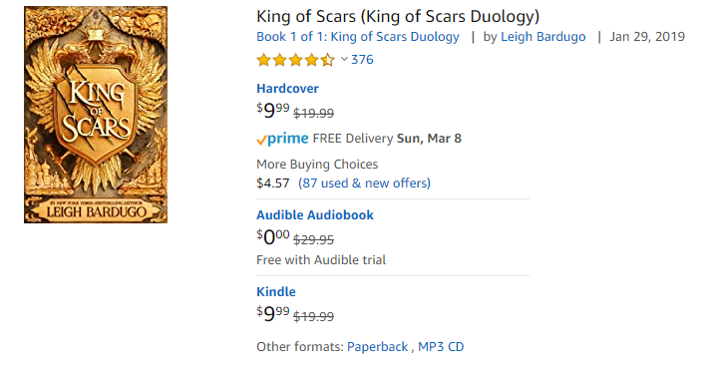

Low estimate
 | 100% | 70% | 40% | 20%
Digital list | $9.99 | $6.99 | $4.00 | $2.00

 | Circs | Cost per circ | Total
Weeks 1 - 8 | 19 | $6.99 | $132.87
Weeks 9 - 52 | 79 | $4.00 | $315.68
> 52 weeks | 10 | $2.00 | $19.98
 |  | Total | $468.53
 |  | Previous total | $160.00
 |  | % change | 193%

Summary: under this model, we would spend $468.53, 193% more than we spent a year ago, to provide the same level of service.

High estimate

 | 100% | 70% | 40% | 20%
Digital list | $19.99 | $13.99 | $8.00 | $4.00

 | Circs | Cost per circ | Total
Weeks 1 - 8 | 19 | $13.99 | $265.87
Weeks 9 - 52 | 79 | $8.00 | $631.68
> 52 weeks | 10 | $4.00 | $39.98
 |  | Total | $937.53
 |  | Previous total | $160.00
 |  | % change | 486%

Summary: under this model, we would spend $937.53, a 486% increase, to provide the same level of patron service.

Proposal #3: bundles of checkouts
With this book, we purchased all four of our copies within a month of the street date, which means, with a 7:1 holds ratio, that there were at least 28 and at most 34 requests in the first month. We did not buy any more copies after that, so the request count probably held steady. In this case, I am going to estimate for the first 8 weeks at demand of 31 one requests on top of the 12 checkouts that the 4 copies will have received in the first eight weeks.
As with the previous book, we will estimate that the demand for the book in weeks 9-16 and thereafter is even.
 | Est. demand | Bundle cost per 10 SU circs | Bundles required | Total
Weeks 1 - 8 | 43 | $70.00 | 5 | $350.00
Weeks 9 - 16 | 33 | $60.00 | 4 | $240.00
Weeks 17 - 26 | 33 | $40.00 | 3 | $120.00
> 26 weeks | 0 | $20.00 | 0 | $0.00
 |  |  | Total | $710.00
 |  |  | Previous total | $160.00
 |  |  | % change | 344%

Summary: under this model, we would spend $710 for 109 circulations of a book like King of Scars, an increase of 344%.
And I note again that this is probably a very conservative estimate.

The Remarkable Journey of Coyote Sunrise by Dan Gemeinhart

This is an interesting title, because we bought several copies over several months rather than buying several in the very beginning.
Audience: Juvenile Fiction
Street date: 1/8/2019
Circulation between 1/1/2019 – 3/4/2019: 107
Actual spending
Price per copy | $40.00
Copies purchased | 4
Total spent | $160.00

Proposal #1: $80 in weeks 1-8, $60 in weeks 9-52, $50 thereafter

 | Cost per copy | Copies purchased | Total cost
Weeks 1 - 8 | $80.00 | 1 | $80.00
Weeks 9 - 52 | $60.00 | 3 | $180.00
> 52 | $50.00 | 0 | $0.00
 |  | Total | $260.00
 |  | Previous total | $160.00
 |  | % change | 63%

Summary: under this model, we would pay 63% more for the same level of service.

Proposal #2: pay-per-circ indexed to digital list price

Here are the numbers we will be using for our high and low estimates
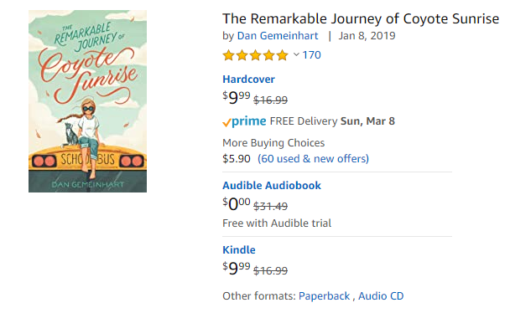

Low estimate
 | 100% | 70% | 40% | 20%
Digital list | $9.99 | $6.99 | $4.00 | $2.00

 | Circs | Cost per circ | Total
Weeks 1 - 8 | 2 | $6.99 | $13.99
Weeks 9 - 52 | 84 | $4.00 | $335.66
> 52 weeks | 21 | $2.00 | $41.96
 |  | Total | $391.61
 |  | Previous total | $160.00
 |  | % change | 145%

Summary: with this model, we would spend 145% more on a book like this than we did a year ago.

High estimate

 | 100% | 70% | 40% | 20%
Digital list | $16.99 | $11.89 | $6.80 | $3.40

 | Circs | Cost per circ | Total
Weeks 1 - 8 | 2 | $11.89 | $23.79
Weeks 9 - 52 | 84 | $6.80 | $570.86
> 52 weeks | 21 | $3.40 | $71.36
 |  | Total | $666.01
 |  | Previous total | $160.00
 |  | % change | 316%

Summary: with this model, we would spend 666.01, 316% more than we spent last year in order to provide the same level of service to patrons.

Proposal #3: bundles of checkouts

Since we purchased several copies of this title over time, it is difficult to measure the demand. We assume that the holds ratio drove the purchases.
Purchase dates | Weeks after street date
2/22/2019 | 6
5/29/2019 | 20
7/16/2019 | 27
7/16/2019 | 27

We can assume that we had at least 7 requests in May and as many as 13, which drove the 5/29 purchase. Then, the July purchase would have reflected the same behavior. (The second July copy is an Advantage copy). We will estimate as follows:
Two readers wanted the book in weeks 1-8, which we know because they checked it out.
In weeks 9-16, 4 readers checked out the book.
21 readers checked out the book a year after release, so we will a lot these to the last category
In weeks 17-26, enough interest grew in the book to merit the purchase of 3 more copies in weeks 20 and 27 respectively, therefore we will allot the rest of the readers to that category.

 | Est. demand | Bundle cost per 10 SU circs | Bundles required | Total
Weeks 1 - 8 | 2 | $70.00 | 1 | $70.00
Weeks 9 - 16 | 4 | $60.00 | 1 | $60.00
Weeks 17 - 26 | 80 | $40.00 | 8 | $320.00
> 26 weeks | 21 | $20.00 | 2 | $40.00
 |  |  | Total | $490.00
 |  |  | Previous total | $160.00
 |  |  | % change | 206%

Summary: in this model, we spend 206% what we would have spent a year ago, but for a slightly better patron experience since the licenses are simultaneous use.

The Silent Patient by Alex Michaelides

Audience: Adult fiction
Street date: 2/5/2019
Circulation between 1/1/2019 – 3/4/2019: 551
Note: we had 803 total circs because several Advantage libraries purchased copies, but I am not counting the circs or copies here to keep things simple.
Actual spending
Price per copy | $40.00
Copies purchased | 17
Total spent | $680.00

Proposal #1: $80 in weeks 1-8, $60 in weeks 9-52, $50 thereafter

 | Cost per copy | Copies purchased | Total cost
Weeks 1 - 8 | $80.00 | 16 | $1,280.00
Weeks 9 - 52 | $60.00 | 1 | $60.00
> 52 | $50.00 | 0 | $0.00
 |  | Total | $1,340.00
 |  | Previous total | $680.00
 |  | % change | 97%

Summary: with this model, we would pay $1340.00, 97% more, for the same level of service.

Proposal #2: pay-per-circ indexed to digital list price

These are the numbers we will use to calculate a high and low estimate.
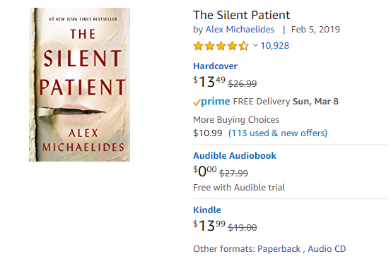

Low estimate
 | 100% | 70% | 40% | 20%
Digital list | $13.99 | $9.79 | $5.60 | $2.80

 | Circs | Cost per circ | Total
Weeks 1 - 8 | 77 | $9.79 | $754.06
Weeks 9 - 52 | 438 | $5.60 | $2,451.05
> 52 weeks | 36 | $2.80 | $100.73
 |  | Total | $3,305.84
 |  | Previous total | $680.00
 |  | % change | 386%

Summary: the same level of service will cost 3,305.84 for a popular book like this, an increase of 386%.

High estimate

 | 100% | 70% | 40% | 20%
Digital list | $19.00 | $13.30 | $7.60 | $3.80

 | Circs | Cost per circ | Total
Weeks 1 - 8 | 77 | $13.30 | $1,024.10
Weeks 9 - 52 | 438 | $7.60 | $3,328.80
> 52 weeks | 36 | $3.80 | $136.80
 |  | Total | $4,489.70
 |  | Previous total | $680.00
 |  | % change | 560%

Summary: if the digital list price is $19.00, then a popular book like this will cost $4489.70, an increase of 560%.

Proposal #3: bundles of checkouts

With this book, because we purchased 16 copies within the first 8 weeks, we know that there were at least 112 requests. Combined with the 77 checkouts, we will estimate demand from 189 readers in the first 8 weeks.
We purchased another copy in week 11, indicating approximately 10 new requests at that time. In combination with the 89 checkouts in week 9-16, we will estimate demand for those weeks at 99.
We will split the rest of the demand between the last two categories.
 | Est. demand | Bundle cost per 10 SU circs | Bundles required | Total
Weeks 1 - 8 | 189 | $70.00 | 19 | $1,330.00
Weeks 9 - 16 | 89 | $60.00 | 9 | $540.00
Weeks 17 - 26 | 137 | $40.00 | 14 | $560.00
> 26 weeks | 136 | $20.00 | 14 | $280.00
 |  |  | Total | $2,710.00
 |  |  | Previous total | $680.00
 |  |  | % change | 299%

Summary: with this model, we pay 300% more for the same number of readers, but they get to read the book when they want to, rather than waiting.

