Using OverDrive features to filter certain publishers out of search results

# Overview

**What problem are we trying to solve?**

My library has accidentally purchased some titles from publishers we are currently boycotting, and it has created some extra work. (They were mostly popular titles that patrons requested individually, and we are not buying added copies, so the holds queues are so long that we are thinking of contacting the patrons to let them know about alternative formats)

**Proposed solution**

Document the different features in Marketplace that help selectors check carts before ordering and filter publishers out of search results as they consider what to buy.

The document includes:

* Regular selection carts
* Smart carts
* Selection lists
* Title-by-title search

# Carts

**Checking selection list carts before ordering**

There is no filter in Marketplace at this time that allows us to perfectly avoid content currently affected by embargoes or boycotts. To make sure that boycotted materials aren’t accidentally purchased, selectors are asked to follow these simple steps before submitting carts. Please check every cart before purchase.

1. Log in to Marketplace and navigate to the cart you intend to purchase.



1. Open your cart. Sort content by the *Publisher* field. Use the *Add/Remove Columns>* tool to make the table more readable, as needed.

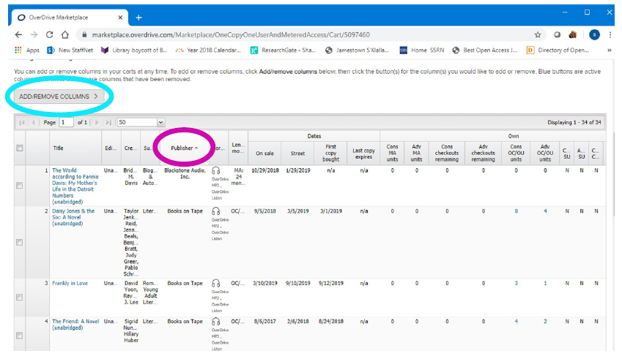

3. Visually scan the alphabetical listing for publishers whose content the library or consortium is currently boycotting.

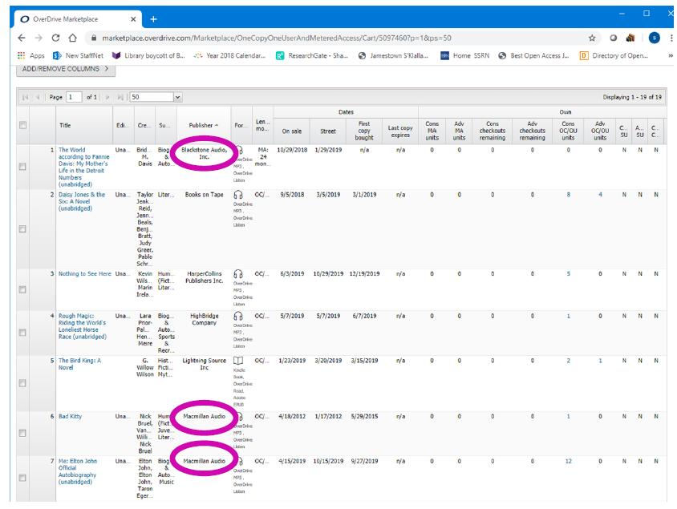

4. Highlight boycotted titles by clicking the check box at left.

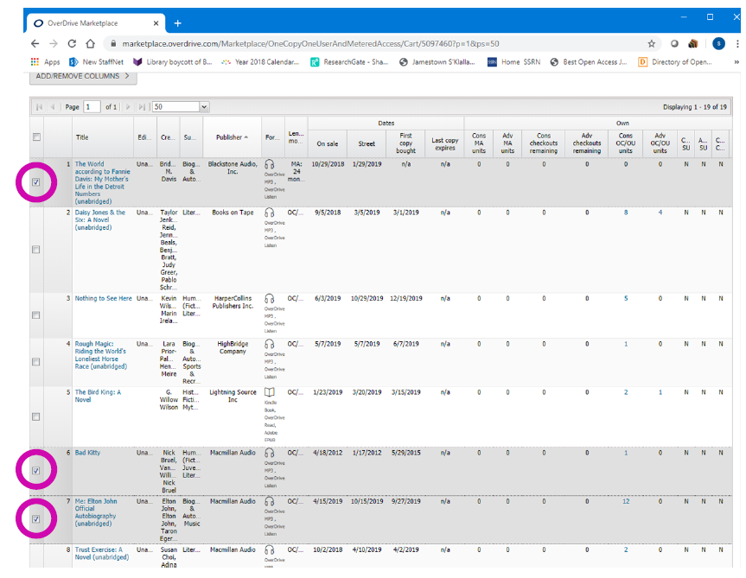

5. Above the cart contents, use the red *X Delete Title(s)* button to remove these boycotted items from your cart.

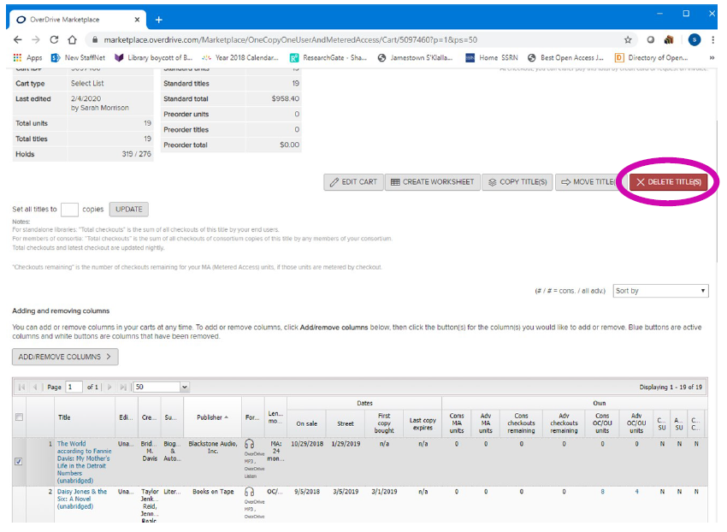

6. Complete the *Delete title(s)* dialogue box that appears.

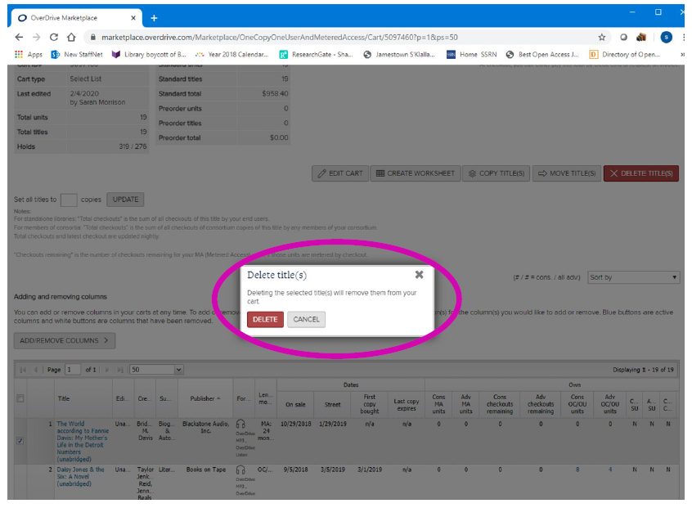

7. Visually check that your cart is now boycotted-content –free.

**Smart carts**

If you use smart carts, you can edit them to include all publishers except those you are not purchasing from at this time.

1. Click the Shop dropdown and then click Automate Carts.

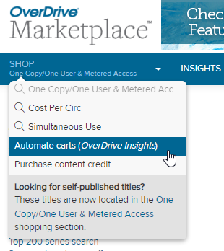

1. Click Smart Lists and then click the Smart Cart you want to edit.
2. Scroll down to the Publishers section, multi-select all of the publishers and add them to the Include only field. Then, remove the ones you do not want to buy from the Incude only field.

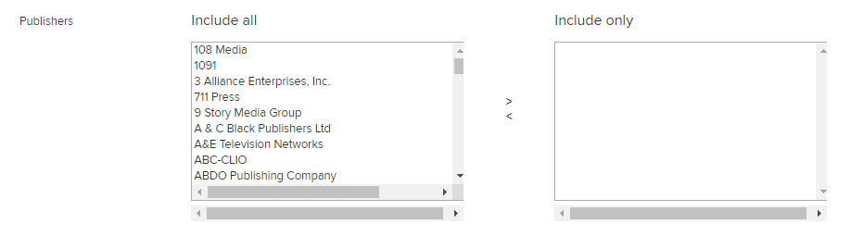

(We have not tried editing our smart carts in this way, so don’t know if it works)

# Search results

**Lists**

If you use any of the lists in OverDrive, such as the Top 200 adult titles, or the lists under the Featured menu, you can use the new search facets to exclude certain publishers.

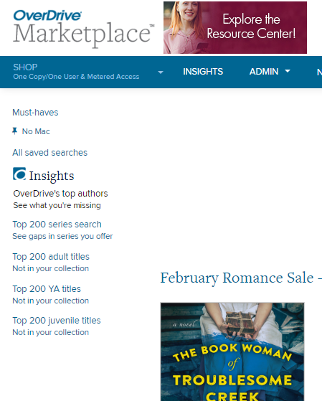

1. Click a list, such as Top 200 nonfiction eBooks not in your collection
2. When the search results load, scroll down until you see the Publisher account section in the left nav facets.

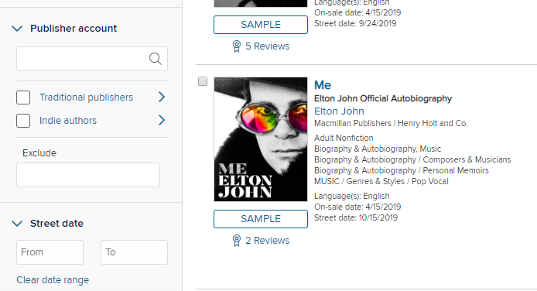

1. In the Exclude box, type the name of the Publisher you want to exclude. A smart menu will pop up and you can select the name there. Then click Apply. (Note that in the image below, the Elton John biography is gone)

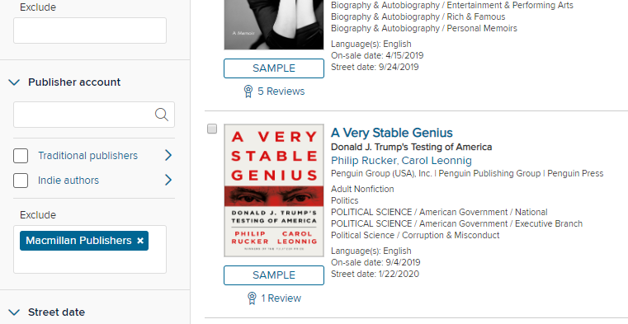

**Title searches**

The left nav facets do not work well for title searches because you cannot save them. You can, however, save an Advanced search and use that saved search for title searching if you want to be sure not to mistakenly let a title sneak into your cart from a publisher you are not buying.

1. Click the Advanced Search dropdown arrow to the right of the main search box.

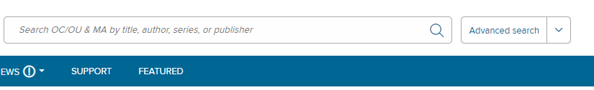

1. Click Create New Saved Search.
2. On the Advanced Search page, enter the parameters you want to use for your search. To exclude a publisher, use the Exclude publisher account dropdown. Depending on how you typically do title searches, you may want to set other criteria.

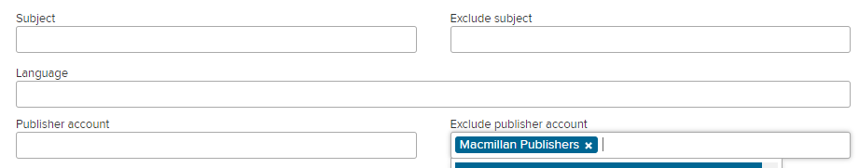

1. At the top of the page, click Save, name your search, select “Pin search to menu” and click Save again.

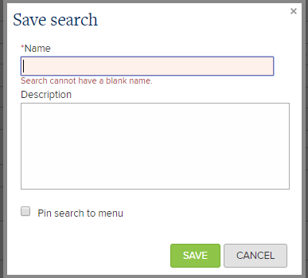

1. When you want to do a title search, click the Advanced Search dropdown and click the Edit pencil next to your saved search. (Clicking the search name itself does not navigate – I don’t know why)

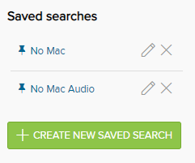

1. Enter the title you want to find in your search criteria. If it is a title that should be filtered out per your criteria, you will get no search results.

