Hello, selectors,

This email will provide information on how to carry out the WDLC’s approved boycott on Macmillan eContent.

The WDLC boycott will run November 1, 2019 through December 31, 2020, and includes all Macmillan eContent, both eBooks and eAudiobooks, both new releases and backlist titles. In the event that Macmillan drops their embargo, the WDLC will immediately drop our boycott; you will be notified if such an event occurs.

Because Macmillan is a Big 5 Publisher, they have acquired many small publishers. These imprints are part of the Macmillan “family” but publish under their own names, so Macmillan content might appear in a number of ways:

When looking at titles in Marketplace Shop:
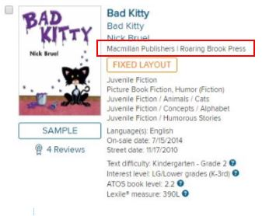

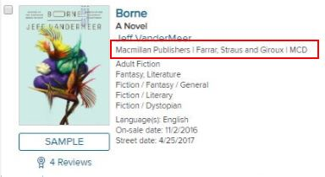
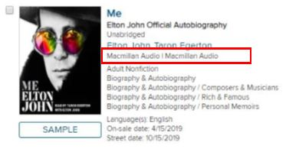

When looking at titles in Cart details:
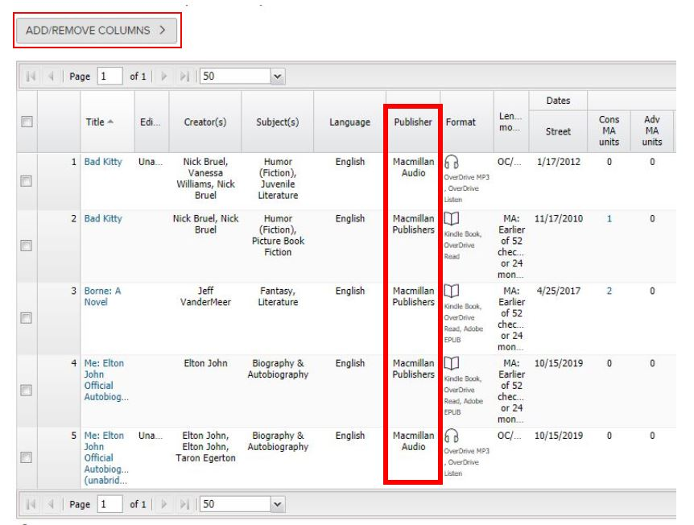
At this time, OverDrive has responded to library requests and made all Macmillan imprints appear under one easily-identifiable name. Please be aware that this functionality may change without notice. Check publisher information carefully!

The Add/Remove Columns function above the cart can help you eliminate cluttering information you don’t need. You can use the drop-down arrow in the top of each column to sort by Publisher. Please sort each cart and check for Macmillan titles before purchasing. As we’ve experienced with the Blackstone boycott, it’s unfortunately easy to purchase this content. Accidentally-purchased boycotted titles can add to patron confusion and dissatisfaction, and will reflect negatively on our consortium’s statistics, such as over-all wait times, outstanding holds, etc.

If you find Macmillan titles which have made their way into your cart, you can delete them by checking the box at the left, then clicking the red “Delete Title(s)” button at the bottom right of the cart:
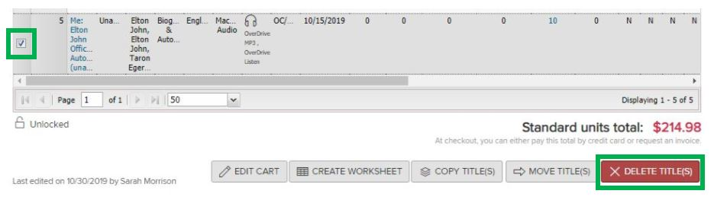

Here is the complete list of imprint names under which Macmillan might publish:
- All Points Books
- Bedford/St. Martin’s
- Castle Point Books
- Celadon Books
- Entangled Publishing
- Entangled Publishing, LLC
- Farrar, Straus and Giroux
- Farrar, Straus and Giroux Books for Young Readers
- Feiwel & Friends
- First Second
- Flatiron Books
- Forge
- FSG Originals
- Graywolf Press
- Griffin
- Hayden-McNeil
- Henry Holt and Co.
- Henry Holt and Co. Books for Young Readers
- Hill and Wang
- Holt Paperbacks
- Imprint
- Kingfisher
- Macmillan Audio
- Macmillan Collector’s Library
- Macmillan Learning
- Metropolitan Books
- Minotaur
- North Point Press
- Odd Dot
- Papercutz
- Picador
- Priddy Books
- Roaring Brook Press
- Sarah Crichton Books
- Scientific American FSG
- Square Fish
- St. Martin's Paperbacks
- St. Martin’s Press
- St. Martin's Publishing Group
- Starscape
- Thomas Dunne Books
- Times Books
- Tom Doherty Associates
- Tor
- Tor Children’s
- Tor/Forge
- Tor Teen
- W.H. Freeman
- Wednesday Books
- Worth Publishers

As we’ve experienced with the Blackstone boycott, it may happen that some Macmillan titles will be added to the collection, or that previously-purchased Macmillan titles will unexpectedly experience a surge in popularity. In those cases, patron interest will quickly outstrip the one or few copies the consortium owns. Depending on the size of your library and available staff time, you may want to set up a system to proactively reach out to local patrons mired on these long holds lists. Below is the process used by one WDLC library, which serves a county-wide population of ~70,000 (54,000+ active cardholders, 3,000+ active OverDrive users) and has Advantage functions turned on. This process takes one staff member less than one hour per week. Response from patrons has been entirely positive.

- Log in to Marketplace using Advantage credentials.
- Use a Saved Search based on Hold Ratio. Ask OverDrive support for help setting up a Saved Search. If you have a Saved Search, edit settings so that Holdings are set to Any.
- Visually scan these high-holds items (or use the Find function in your browser) and note which titles will be ineligible to order. For example, for the Blackstone eAudio title Talking to strangers by Malcolm Gladwell, 1 copy was ordered. As of 10/30/19, there were 286 holds throughout the consortium.
- Under the Support tab, access the Manage Holds tool (under End-user support).
- Search by title.
- You will be given a table which does not have an Export function. Copy all the information and paste it into an Excel document.
- Sort this sheet and delete information related to hold for patrons at other libraries.
- Separate by format so slightly customized emails can be sent to patrons waiting for eBooks vs. eAudiobooks.
- Email patrons regarding their long wait times. An example email can be found on the Blackstone Tool Kit page; update as needed. Email patrons individually or use BCC so that patron privacy is protected.
- Repeat steps 5-9 for each separate title. The example library sends emails related to 3-6 titles per week. The largest outlay of staff time occurs when a new title is accidentally added and quickly accumulates a holds list; contacting the 1-5 new additions per week thereafter is a quicker process.
- Track which patrons are contacted each week; you can save considerable time by contacting patrons only the first time they appear on the holds list.

Most of these notification emails to patrons, like all library communications, generate no feedback. What responses this library received, however, have been entirely positive. A selection of replies to notifications regarding long wait times on Blackstone titles:
- “Thank you for reaching out and explaining the situation. I fully support your decision to join other libraries in a boycott, and hope it’s successful. I really like all the materials I have been able to access through Libby, and all the other great services and products offered by [Library]. I am glad you continue to advocate for public access. Thank you!”
- “Thanks. I will continue to hold for the audio version as I listen while walking. Sorry to hear of the dilemma with Blackstone.”
- “Thank you. 👍”
- “Thank you. I have asked for a hold on the print version already.”
- “Wow, thanks for letting me know! ‘Prohibiting libraries…’ just sounds wrong, doesn’t it!? I had no idea. I knew about Hachette strongly protecting their copyrights, but fair sales is different than ‘prohibiting’ sales! I will cancel my hold, thanks.”
- “Thanks for the heads-up on Blackstone. I wholeheartedly support your boycott based on that publisher's predatory strategy. I requested the audio version only because there was no printed version offered through the Washington On-line library. Sometimes the Kindle version is just more convenient, but I'm equally happy to read a printed edition, so I have just placed a hold on a print version through my [Library] account at the [Branch] branch. Thanks again. I will cancel my hold on Overdrive.”

One final note for libraries with Advantage Plans: OverDrive has confirmed that, along with the embargo on new content, existing titles owned in local Advantage collections will be ineligible for sharing. After the boycott and/or embargo have ended, libraries will want to check the status of this publisher decision before adding Macmillan content to local Advantage collections.

