Analyzing titles and circ from Macmillan in OverDrive collections

Goals:
- Determine what percentage of eBooks and eAudiobooks in an OverDrive collection come from Macmillan
- Determine what percentage of total circ comes from Macmillan
- List top selling titles and authors

- Sign in to Marketplace, click Insights in the top nav, and then click Title status & usage in the left nav.
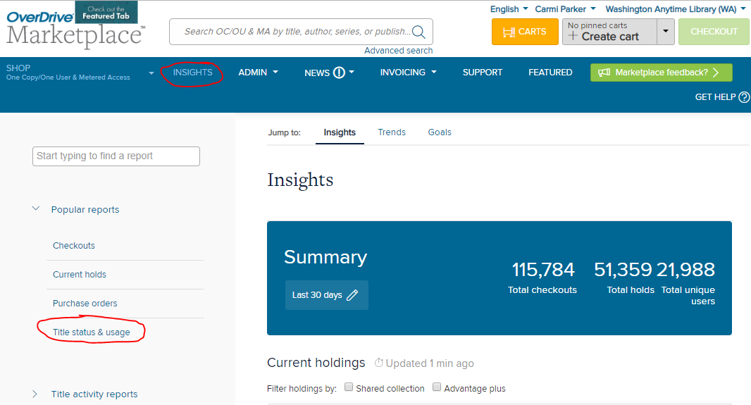

- Click Run new report
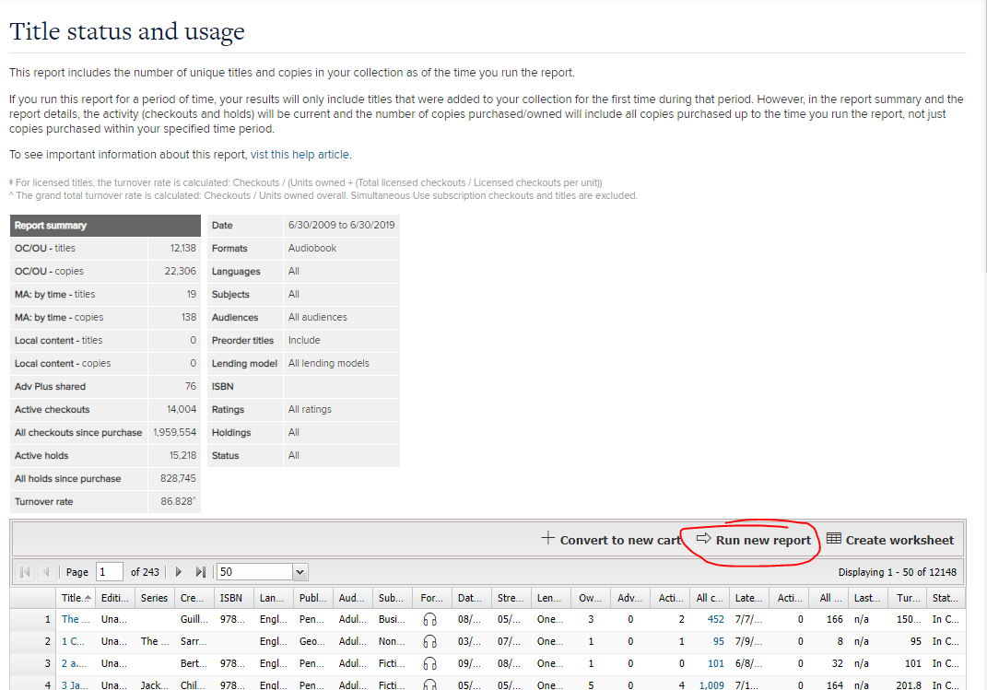

- On the Report options dialog, select the following
Title: Leave blank
Period type: Specific
Start date: 09/01/2009
End date: 8/31/2019
Formats: All formats
All else: copy those in the image below
Click Update.

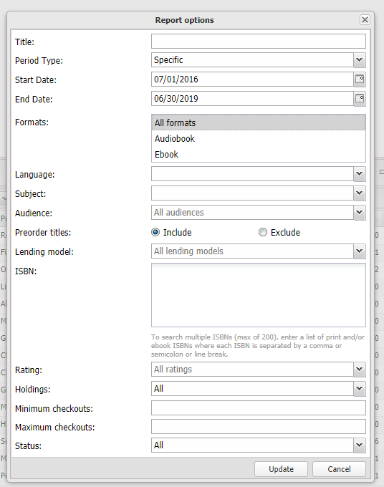

The report outputs all the titles in your collection over the last 10 years so you should expect it to have many rows.
Click Create worksheet in Marketplace, which will generate an .csv download. The file will be large, with many data points, so it is not surprising if it takes a minute or two.
Save the csv as an xlsx file. For some reason, the Save dialog defaults to a txt file extension so you have to change that.
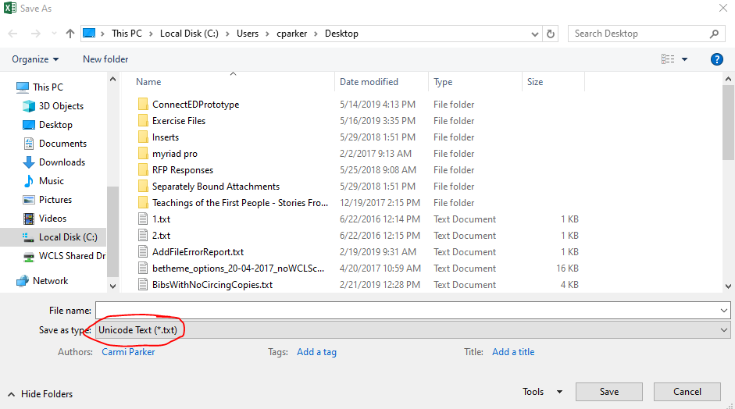

- In Excel, select cell A1 and make sure you have the Home ribbon selected. Then select Format as Table, select a table style, and review the dialog that pops up to make sure the range that Excel selects looks correct and the “My table has headers” checkbox is enabled . Formatting as table adds helpful sorting and filtering controls to all your columns.
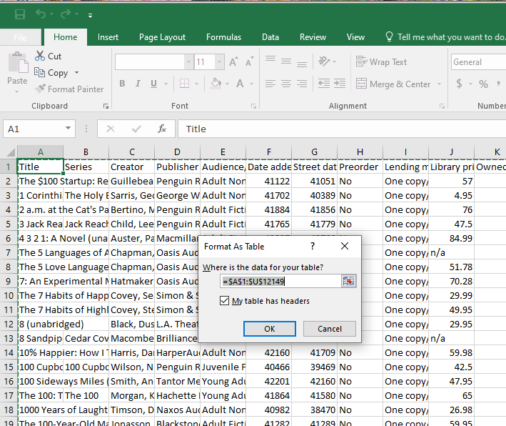

- Scroll right and select the column that says “All Checkouts”
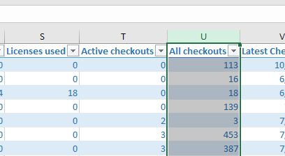
Then, view the information that Excel shows about the selection at the bottom right of the screen.
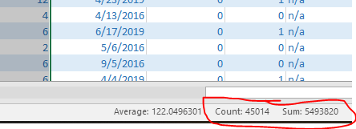
The Count is the total number of titles. The Sum is the total number of checkouts on those titles.
- Add a new worksheet to Excel and type these numbers into the cells there. Here’s how I did it.
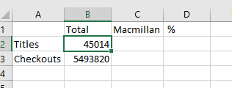
- Return to the worksheet with all the titles and scroll back to the left and view the Publisher heading.

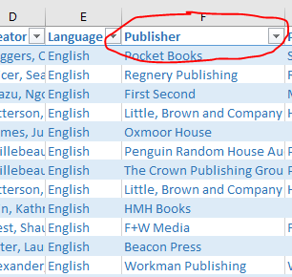
- Click the Publisher dropdown and clear the Select All checkbox
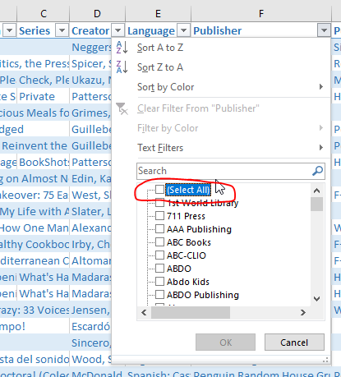
- Scroll through the checkbox list of publishers and select the values below. This will be the most painful part of this analysis, because there will be hundreds of publishers in this list.

- Celadon Books
- Entangled Publishing
- Entangled Publishing, LLC
- Farrar, Straus and Giroux
- Farrar, Straus and Giroux (BYR)
- Feiwel & Friends
- First Second
- Flatiron Books
- Graywolf Press
- Henry Holt and Co.
- Henry Holt and Co. (BYR)
- Imprint
- Macmillan Audio
- Papercutz
- Picador
- Roaring Brook Press
- Square Fish
- St. Martin's Press
- St. Martin's Publishing Group
- Tom Doherty Associates
These are the values that Macmillan puts in the OverDrive Publisher field. We checked this list with OverDrive and they agreed that these values are associated with Macmillan.
On the checkbox list, click OK. Now your list of titles is filtered just to Macmillan.

- Scroll back to the All Checkouts column and select it again.
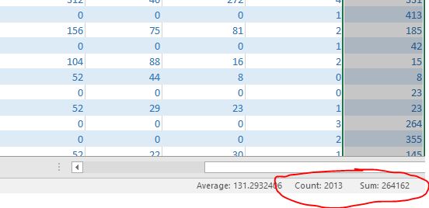
The Count is the total number of Macmillan titles in your collection.
The Sum is the total circulation on Macmillan titles
- Copy the Sum and Count into the table on your new worksheet
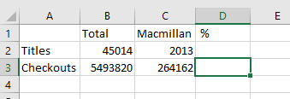
- Calculate the percent of Macmillan titles and circulation.
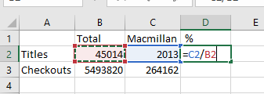

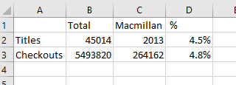
- To view the top circing authors and titles, return to the list of titles and click the dropdown for All Checkouts. Sort by Largest to Smallest
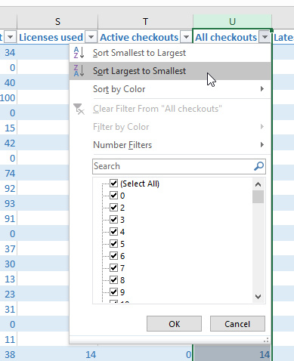

- Scroll back to the left to view the top titles and authors
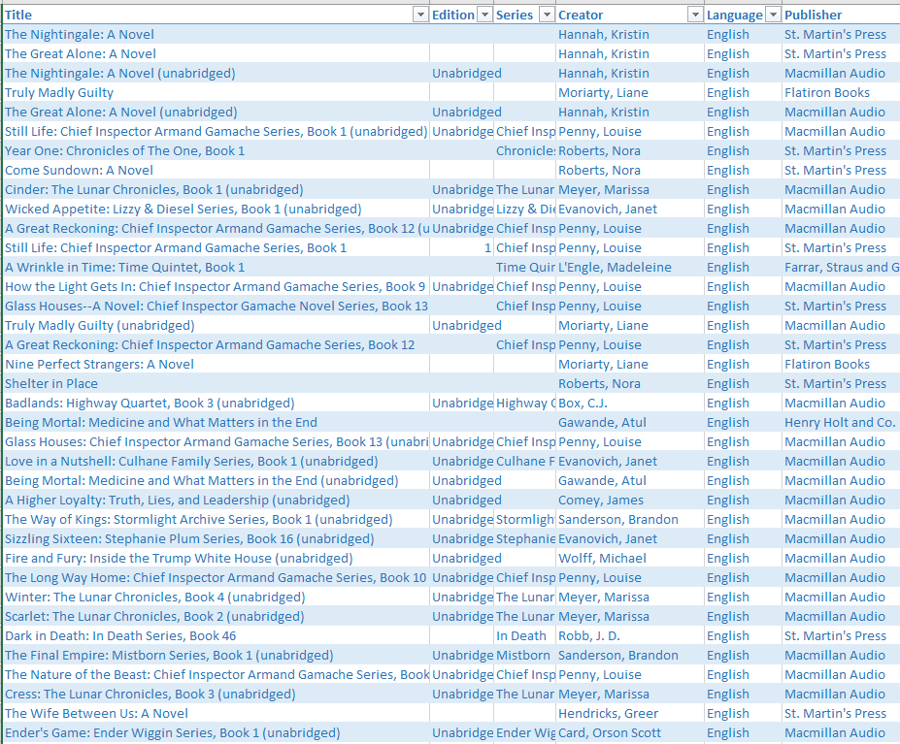
If you want, you can use the Format dropdown to filter eBooks versus eAudiobooks.

