**PROPOSAL**

Boycott Blackstone Audio for 6 months (August 1, 2019 – January 31, 2020), purchasing no new or added copies of their eAudiobooks in order to protest their embargo on library sales beginning July 1, 2019.

Invite other library systems to join us in the boycott to maximize its impact.

**What problem are we trying to solve?**

The Blackstone embargo is the second to occur recently. Last summer, Tor Publishing did the same. And Hachette and Simon & Schuster both recently announced that they will change eAudiobooks from perpetual access to a metered access model, which will cost libraries more over time for the same materials. We are concerned about the pattern we see, with multiple publishers creating barriers for libraries and limiting access for library patrons. If publishers are permitted to continue creating these barriers unchecked, we believe more barriers will occur. We wish to use our purchasing power to communicate to Blackstone and other publishers that libraries are customers who add value to the publishing ecosystem. Moreover, we have an ethical obligation to maximize patron access to materials and get the best possible value for our taxpayer dollars. Working with partners who are willing to impede patron access puts those obligations at risk.

**What outcome do we want to see?**

Blackstone Audio will take steps to stop the embargo.

Other publishers will rethink the premise that libraries will continue to do business with them regardless of the barriers publishers implement.

**What do you need to do in order to join the Washington Digital Library Consortium (WDLC) in the boycott?**

1. Review the letter to Blackstone and the email to OverDrive. These are posted in the toolkit [here](https://www.wcls.org/library-boycott-of-blackstone-audio/).
2. Get approval from the appropriate decision makers at your library. We have included possible stakeholder talking points in the toolkit.
3. Email us that you would like to join no later than 12:00 PM, Wednesday, July 17, 2019. We will be emailing the boycott announcement to Blackstone and OverDrive on July 18, 2019 and will include the name of your institution, if you wish.

Sarah Morrison ([smorrison@nols.org](mailto:smorrison@nols.org))

Carmi Parker (carmi.parker@wcls.org)

1. Prepare selectors and staff for the boycott implementation.
2. Implement it!

**Important:** If you can’t join WDLC’s boycott, we still encourage you to create a boycott of your own. Perhaps your decision-makers aren’t available or your library is more comfortable with a three-month boycott rather than six. You are welcome to adapt for your own use any of the resources in the online toolkit, which includes:

* This proposal, including patron impact analysis and logistics for selectors
* Our letter to Blackstone
* Our email to OverDrive
* Sample press release
* Talking points for stakeholders
* Q&A for staff and patrons
* FAQs for library staff considering a boycott

If you create your own boycott, we would love to hear from you and add your name to our online list of participants!

**PATRON IMPACT**

**How much of the catalog is represented by Blackstone?**

We analyzed the eAudiobook titles in the WDLC collection. Blackstone was listed as the publisher for about 20% of our total eAudio collection. Of all the Blackstone titles in our collection, 86% are titles for which we own only 1 or 2 copies, making them firmly mid-list.

(If you would like to do an analysis on our own collection, we will add a step-by-step guide to the appendix.)

There are titles, however, that are scheduled for publication during our proposed boycott window. Asking our patrons to wait for these titles will be unpopular. In particular, we note:

|  |  |  |  |  |  |
| --- | --- | --- | --- | --- | --- |
| Author | Title | Est, print pub date | Available in MarketPlace | Preordered | End of Boycott period |
| Douglas Preston | Old bones | 8/20/19 | No | No | 2/1/20 |
| Michael Connelly | The night fire | 10/22/19 | No | No | 2/1/20 |
| David Baldacci | A minute to midnight | 11/19/19 | No | No | 2/1/20 |
| James Patterson | Criss Cross | 11/25/19 | No | No | 2/1/20 |
| James Patterson | 19th Christmas | 10/7/19 | No | No | 2/1/20 |
| James Patterson | Killer instinct | 9/9/19 | No | no | 2/1/20 |
| James Patterson | The inn | 8/5/19 | No | No | 2/1/20 |
| James Patterson | The warning | 8/13/19 | No | No | 2/1/20 |

**What percentage of patrons will be impacted by having to wait for Blackstone titles?**

Over the last year (June 1, 2018 – May 31, 2019), patrons of the WDLC libraries accumulated 14,713 checkouts on the 218 Blackstone titles added during that time period. That number represents 2.7% of our total eAudio checkouts for the year, and 1.1% of our total checkouts on OverDrive for the year. Since our boycott is six months, not a year, we expect approximately half that number of patrons to be impacted.

To help you estimate this figure for yourself, we will add a step-by-step guide in the appendix. Note that these numbers represent total checkouts, not unique users; as many users will return and borrow again and again, a smaller number of patrons will likely be impacted.

**Will you order the popular books after the embargo is over? Won’t this just delay Blackstone’s profits?**

Yes, we plan to order any eAudiobooks that patrons have requested once the boycott period expires. As the eAudiobooks will no longer be brand new, we expect demand to be less, which will likely impact the number of holds placed and therefor the number of added copies the WDLC will be required to purchase.

Our intent is not to negatively impact Blackstone’s earnings, but to demonstrate 1) the importance libraries play in helping users discover new materials, which has a profound impact on publisher profits over time, and 2) the impact libraries can have when organized around a common goal for the good of our patrons. Neither do we intend to deprive patrons of materials they enjoy, and the WDLC libraries plan to provide titles through Book on CD, print, Large Print, and eBooks to keep titles available to patrons in as many ways as possible.

**SELECTION LOGISTICS**

**Choosing what not to buy**

WDLC has chosen not to buy any eAudiobook titles from Blackstone Audio, including popular thrillers that we know patrons will miss. That said, we considered a less impactful boycott model and have shared the details below. We invite you to define the parameters of your boycott in a way that works best for your library and patrons. You do not need to follow our model exactly in order to join us.

Details:

Blackstone Audio appears to think about its collection in two categories:

* Blackstone Only: Its “own” titles, which include authors Karin Slaughter, Don Winslow, and Meg Gardiner
  + Shorter list of titles
  + Authors are less popular
  + May be impacted by the embargo
* Blackstone Partners: Its partner titles, which include authors Douglas Preston, Michael Connelly, David Baldacci, and James Patterson.
  + Longer list of titles
  + Authors are more popular
  + Will likely not be impacted by the embargo

Blackstone communicated with us that only their “own” authors are candidates for embargo, but they did not share which authors specifically. They did confirm that none of the authors below will be embargoed.

* Kate Atkinson
* David Baldacci
* M.C. Beaton
* Michael Connelly
* Robert Galbraith (J.K. Rowling)
* James Patterson
* Douglas Preston
* Michael Robotham
* David Sedaris
* Nicholas Sparks

In response to the embargo and lack of complete information, WDLC considered whether to boycott just the Blackstone Only or to boycott Blackstone + Partners.

The pros & cons we considered are:

Boycott Blackstone Partner titles

|  |  |
| --- | --- |
| Pros | Cons |
| Bigger $$ impact to Blackstone: get their attention | Limits patron access to more titles |
| Makes a bigger statement to other publishers considering barriers to library customers | More patrons impacted since we’re boycotting popular titles |
| May create $$ impact on Blackstone’s partners | More work for staff to manage patron impact |
| May be easier for selectors |  |
| Easier to communicate to stakeholders |  |
| More opportunity to educate to patrons |  |

Boycott Blackstone Only titles

|  |  |
| --- | --- |
| Pros | Cons |
| Limits patron access to fewer titles | Less financial impact to Blackstone—less “important” to them |
| Fewer patrons negatively impacted | Less likely to be noticed/taken seriously by other publishers |
| Less work for staff to manage negative patron impact | If not successful, possibly need to reorganize for a 2nd tier of boycotting |
|  | More difficult for selectors to implement |
|  | More difficult to communicate |
|  | Fewer patrons impacted = fewer patrons educated ? |

We believe that either of the above models are appropriate ways to approach the boycott and that other libraries may create other valid parameters, which will work best for them and their patrons. We hope that you will join us, no matter how you decide to coordinate the details.

**How we think it will work in Marketplace**

We believe it is mostly possible to tell the difference between Blackstone Only vs. Blackstone + Partner in OverDrive’s Marketplace as follows:

Blackstone Only: The publisher data will show only Blackstone Publishing

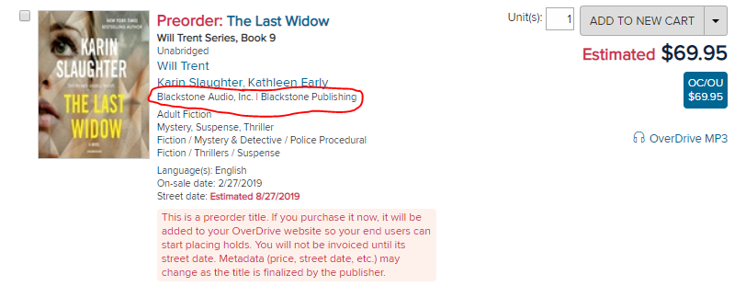

Blackstone + Partners: The publisher data will show Blackstone Publishing as well as another publisher

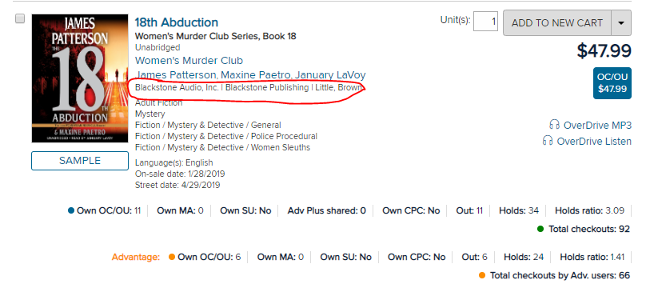

When purchasing:

Our selectors create carts of new titles and will need to review each title in the cart before purchase and remove the Blackstone Audio titles. Publisher information is listed in a column when viewing the cart. (if you don’t see that column, use the “Add/Remove Columns” button to make sure the “Publisher” is selected to blue.) Please note: the sorting function on this column does not actually alphabetize content, so please continue to visually check each field for any Blackstone products. OverDrive is aware that this functionality is faulty but has stated “our developers are aware of the issue” and “we don’t have a timeline for when it’ll be fixed.”

Added copies:

As a consortium, WDLC uses OverDrive’s automated added copy carts that are created weekly based on patron request counts and our holds ratio. Our administrator, who currently reviews the carts before purchasing, will need to remove the Blackstone titles visually as described above. Your process may look similar.

**APPENDIX**

**OverDrive announcement regarding the Blackstone embargo**

**From:** OverDrive <OverDrive@e.OverDrive.com>   
**Sent:** Thursday, June 13, 2019 10:31 AM  
**Subject:** Blackstone Audio update

Effective July 1, 2019, Blackstone Audio will window select audiobook titles for 90 days.

|  |  |  |  |  |  |
| --- | --- | --- | --- | --- | --- |
| |  |  |  |  |  | | --- | --- | --- | --- | --- | | |  |  |  |  | | --- | --- | --- | --- | | |  |  |  | | --- | --- | --- | | |  |  | | --- | --- | | |  | | --- | | [Rakuten OverDrive](https://click.e.overdrive.com/?qs=79c9135181be228fd405f2df473c0a00803c39533b2b9c0ab799cd54391ebdc1655c1ce08022e59e2eb26c4fb231dad4545ceac767f3612f) | | | | | |

|  |  |  |  |
| --- | --- | --- | --- |
| |  |  |  | | --- | --- | --- | | |  |  | | --- | --- | | |  | | --- | | Dear Partner, | | | |

|  |  |  |  |  |
| --- | --- | --- | --- | --- |
| |  |  |  |  | | --- | --- | --- | --- | | |  |  |  | | --- | --- | --- | | |  | | --- | | Effective July 1, 2019, Blackstone Audio will window select audiobook titles for 90 days. Once this change occurs, affected titles in the Blackstone Audio Catalog will be made available for lending distribution 90 days after their retail on-sale date. Existing preorders and titles from their distributed partners (e.g., Hachette Audio, Marvel, Disney, Lucas) will not be impacted by this change. If you have questions or concerns about this change, please contact Blackstone Audio directly at [libraryservices@blackstoneaudio.com](mailto:libraryservices@blackstoneaudio.com). | | Regards, OverDrive | | | |

|  |
| --- |
|  |

|  |  |  |  |  |
| --- | --- | --- | --- | --- |
| |  |  |  |  | | --- | --- | --- | --- | | |  |  |  | | --- | --- | --- | | |  | | --- | | Copyright © 2019 OverDrive, Inc.  All rights reserved.  One OverDrive Way Cleveland, OH, 44125 | | [Privacy policy](https://click.e.overdrive.com/?qs=79c9135181be228fdf9bebc8c13e94855c08077e825446380032415d5cf6ef2e18e655a6886bdb663cd6f44b4c7473b96370264678a0643f) | | | |

**Canned email response from Blackstone when asked for more details**

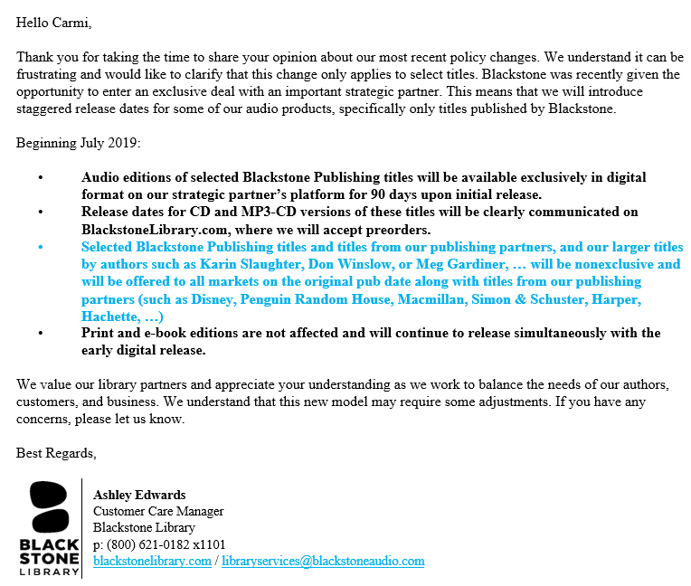

**Guide to analyzing circulation on the Blackstone e-titles in your collection**

Sign in to Marketplace, click **Insights** in the top nav, and then click **Title status & usage** in the left nav.

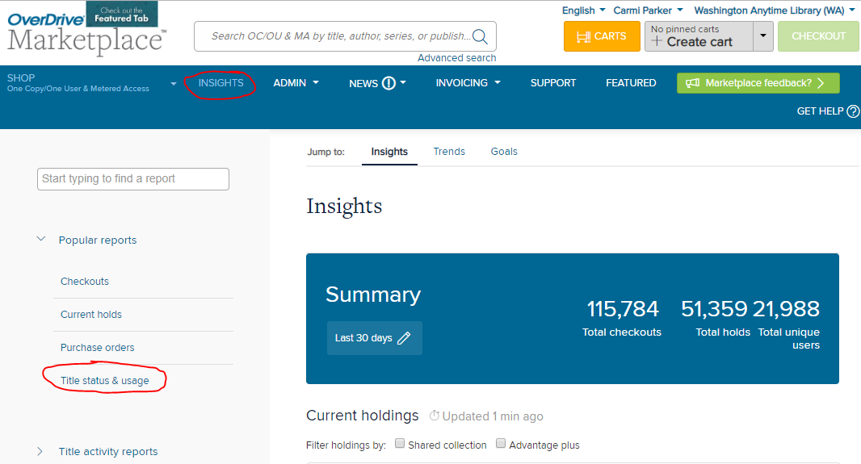

Click **Run new report**

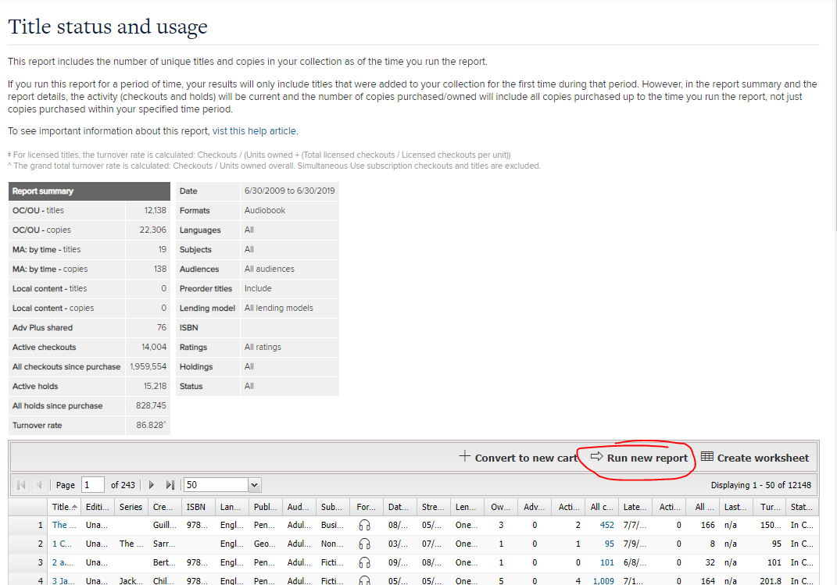

On the Report options dialog, select the following

**Title**: Leave blank

**Period type**: Specific

**Start & end dates**: It’s not clear exactly what dates these are whether they are the date they were added to the catalog, the first date they were available, etc. I choose to cast a wide net here and grab everything from 10 years back. Later, I will filter that data down to titles that were recently added to our catalog)

**Formats**: Audiobook

**All else**: copy those in the image below

Click **Update**.

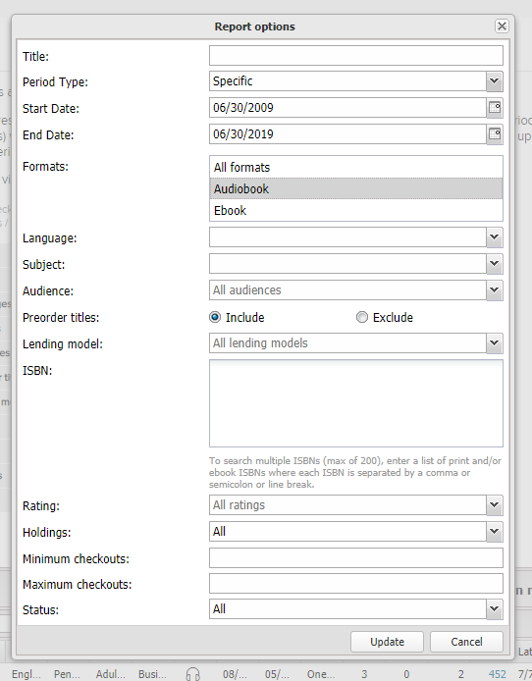

The report outputs all the audiobook titles in your collection over the last 10 years so you should expect it to have many rows. We have 12,148 titles.

Click **Create worksheet**, which will generate an .csv download. The file will be large, with many data points, so it is not surprising if it takes several seconds.

Save the csv as an xlsx file. For some reason, the Save dialog defaults to a txt file extension so you have to change that.

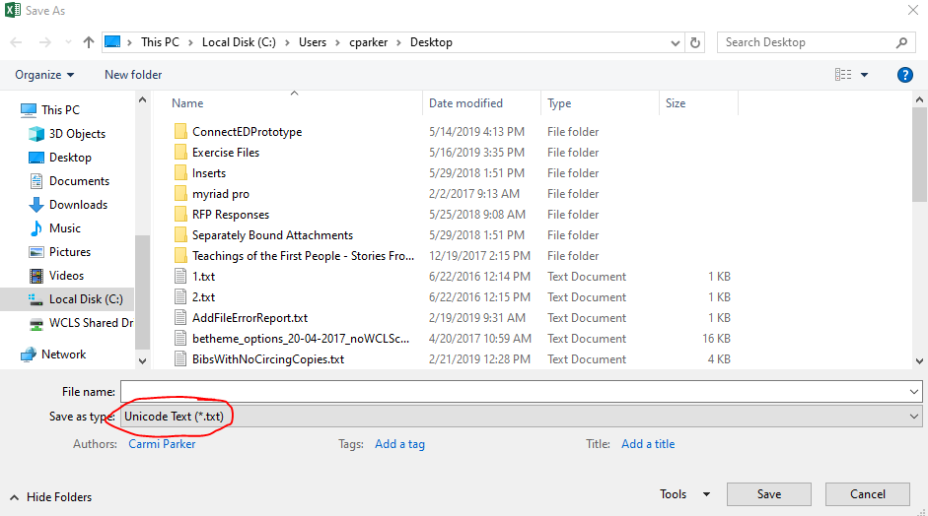

Copy all of the data in the worksheet to a new worksheet. Name the first worksheet “raw” and the second worksheet “working.” This is a best practice in Excel, which will save you from having to download the data again if you make a mistake with the working data.

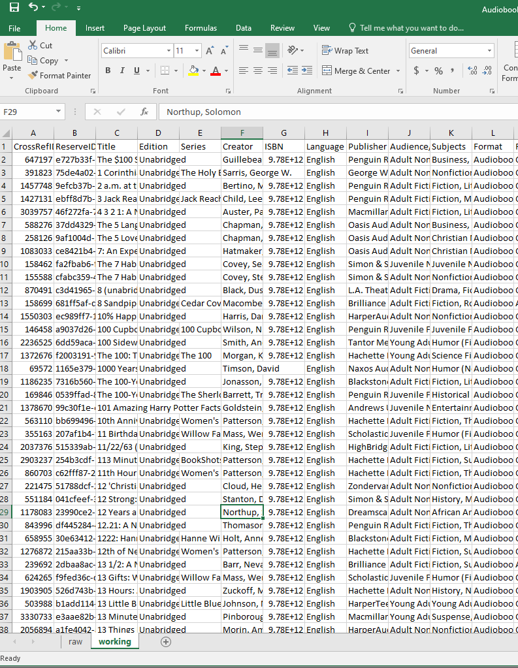

If you want, you can delete columns that you don’t need for your analysis in order to make the data easier to analyse. I usually delete:

* CrossRefID
* ReserveID
* Edition
* ISBN
* Language
* Subjects
* Format
* Formats owned

Select cell A1 and make sure you have the **Home** ribbon selected. Then select **Format as Table**, select a table style, and review the dialog that pops up to make sure the range that Excel selects looks correct and the “My table has headers” checkbox is enabled . Formatting as table adds helpful sorting and filtering controls to all your columns.

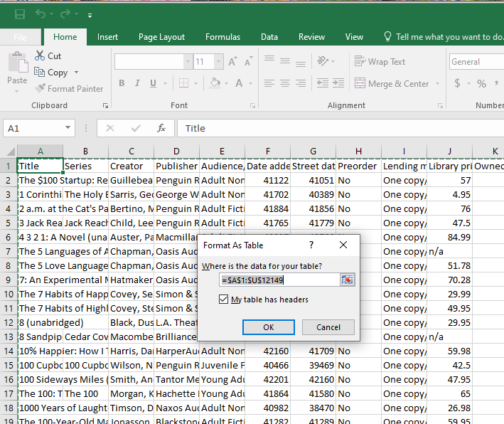

Select the column **Date added to site**, click the **Home** tab, and click the cell formatting dropdown and select **Short Date.**

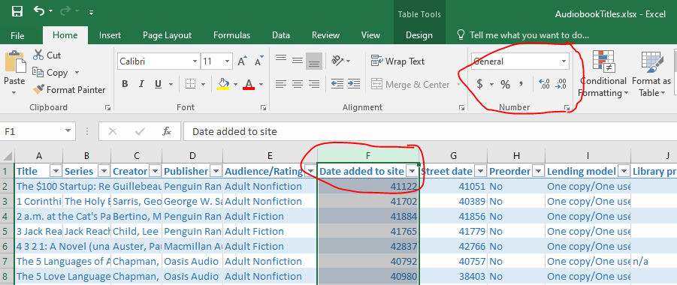

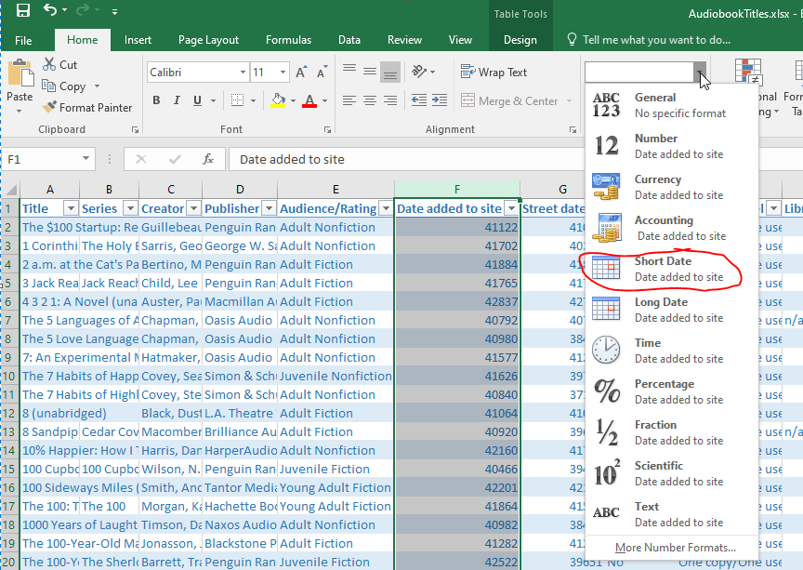

Do this for all the other date columns in the spreadsheet that you think you might use. It allows you to filter by years and months, which is useful for understanding the circ on Blackstone titles in the last 12 – 18 months and anticipating what it might mean if you boycott titles in the next 6 months.

**Save** your work so far

To answer the question, “How many patrons will we be impacting if we boycott Blackstone titles from August 2019 – January 2020”, we did the following:

We filtered the **Date Added to Site** column down to only titles we added between July 2018 – June 2019. The assumption is that most of our circ occurs shortly after the titles are published and that circ diminishes after that into a “long tail.”

If you wish, you can alternatively filter this by **Street date**.

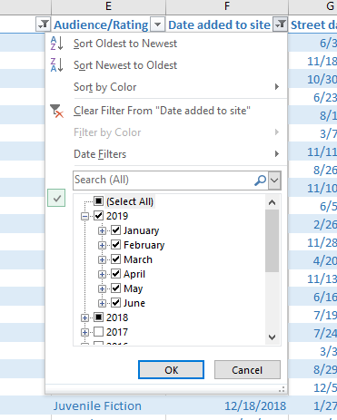

Then, we filtered the **Publisher** column down to the **Blackstone** listings, and we sorted by **Creator** A-Z

We believe that this list represents the titles that Blackstone owns (not their partner titles) with the exception of ones that say things like “Disney Press” and “Marvel Press” in the Creator field. You can use the Creator filter to get rid of these.

Neither Blackstone nor Overdrive are especially careful to make this metadata accurate, so use it to get a ballpark idea of the Blackstone-owned titles in your collection.

To see the most popular titles, you can sort by **All checkouts** or by **Owned**.

Select the **All checkouts** column. The sum total of all the checkouts on your titles will show at the bottom of the screen.

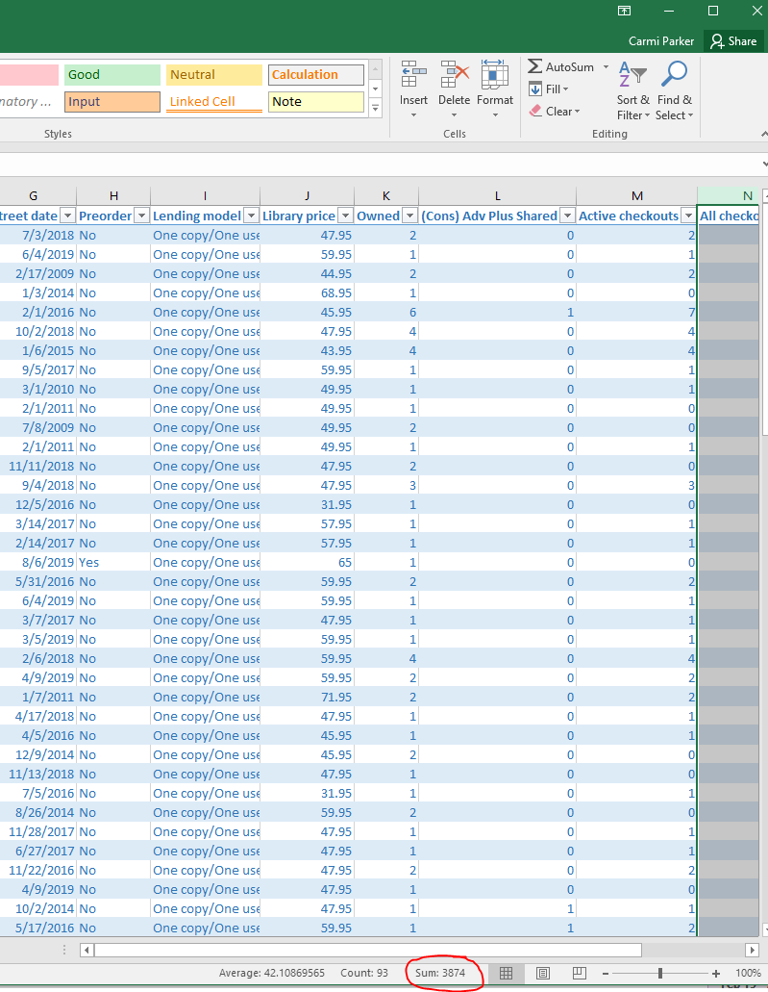

To get an idea of the percentage of circs against all your circs in the time period, remove the filters from the publisher field and check the sum again.

Example: our circs on Blackstone titles total 3874, and our total circs on all the titles during that time period are 77579. So Blackstone’s “own” titles represent about 5% of the total. Since the circs cover a full year, we would estimate that a 6-month boycott will impact about half of that, or 2.5%

Where are the James Pattersons and David Baldaccis?

You may note that titles we think of as Blackstone are missing, such as James Patterson’s *18th Abduction*. When we first pulled this data in late June, those titles did say “Blackstone” in the Publisher field, but have since been adjusted by either Blackstone or OverDrive to show a different publisher (even though Blackstone still creates the eAudiobook). We believe these are the Blackstone “partner” titles we discuss in the proposal.

In order to see your circ on those titles, it is unfortunately necessary to filter by title. Since you are unlikely to want to filter several hundred titles, here are the top 100 that WDLC pulled before the publishing data in Overdrive was changed. We calculated a total of 14, 173 checkouts on all the Blackstone partner titles, and a total of 11, 934 checkouts on the top 100 titles. In other words, the top 100 titles represent 85% of all of our Blackstone partner checkouts for us. If you think that your checkouts are likely to be similar to ours, you can estimate the impact of boycotting Blackstone partner titles by filtering your spreadsheet as follows:

* Your **Date added to site** filter should still be the same date range you set above.
* Your **Publisher** filter should include all publishers
* Your **Title** filter should show the 100 titles below (if you have them in your collection).

When your filters are set, you can again select the **All checkouts** column and see the sum at the bottom of the screen.

The number you see will be about 85% of the total number of patrons who would be impacted if you boycotted for a full year. In order to estimate the impact of a six-month boycott, calculate about half the total checkouts.

100 most popular Blackstone titles at WDLC from June 2018 – May 2019. Includes both Blackstone partners and Blackstone’s own titles.

|  |  |  |
| --- | --- | --- |
| **Title** | **Series** | **Creator** |
| The President Is Missing: A Novel (unabridged) |  | Clinton, Bill |
| The Fallen: Amos Decker Series, Book 4 (unabridged) | Amos Decker | Baldacci, David |
| Dark Sacred Night: Renée Ballard Series, Book 2 (unabridged) | Renée Ballard | Connelly, Michael |
| Long Road to Mercy (unabridged) | Atlee Pine | Baldacci, David |
| Calypso: Essays (unabridged) |  | Sedaris, David |
| Lethal White: Cormoran Strike Series, Book 4 (unabridged) | Cormoran Strike | Galbraith, Robert |
| Texas Ranger (unabridged) |  | Patterson, James |
| Murder in Paradise (unabridged) |  | Patterson, James |
| The Perfect Couple (unabridged) |  | Hilderbrand, Elin |
| The 17th Suspect: Women's Murder Club Series, Book 17 (unabridged) | Women's Murder Club | Patterson, James |
| Tailspin (unabridged) |  | Brown, Sandra |
| Every Breath: A Novel (unabridged) |  | Sparks, Nicholas |
| In Pieces (unabridged) |  | Field, Sally |
| The Pharaoh Key: Gideon Crew Series, Book 5 (unabridged) | Gideon Crew | Preston, Douglas |
| The Indigo Girl: A Novel (unabridged) |  | Boyd, Natasha |
| Pieces of Her: A Novel (unabridged) |  | Slaughter, Karin |
| If Beale Street Could Talk: A Novel (unabridged) |  | Baldwin, James |
| Verses for the Dead: Pendergast Series, Book 18 (unabridged) | Pendergast | Preston, Douglas |
| The Ruin (unabridged) |  | McTiernan, Dervla |
| Redemption: Amos Decker Series, Book 5 (unabridged) | Amos Decker | Baldacci, David |
| Liar Liar: Detective Harriet Blue Series, Book 3 (unabridged) | Detective Harriet Blue | Patterson, James |
| Target: Alex Cross: Alex Cross Series, Book 26 (unabridged) | Alex Cross | Patterson, James |
| Blood of Elves: The Witcher Series, Book 1 (unabridged) | The Witcher | Sapkowski, Andrzej |
| Fellside (unabridged) |  | Carey, M. R. |
| Wrecked (unabridged) | IQ | Ide, Joe |
| Ambush (unabridged) | Michael Bennett Novels | Patterson, James |
| Much Obliged, Jeeves (unabridged) | Jeeves and Wooster | Wodehouse, P. G. |
| The Wife: A Novel (unabridged) |  | Wolitzer, Meg |
| Winter in Paradise (unabridged) | Paradise | Hilderbrand, Elin |
| My Darling Detective (unabridged) |  | Norman, Howard |
| The Bonfire of the Vanities: A Novel (unabridged) |  | Wolfe, Tom |
| Aunts Aren't Gentlemen (unabridged) | Jeeves and Wooster | Wodehouse, P. G. |
| Red Alert: An NYPD Red Mystery (unabridged) | NYPD Red | Patterson, James |
| Transcription: A Novel (unabridged) |  | Atkinson, Kate |
| Cold Barrel Zero (unabridged) |  | Quirk, Matthew |
| The House Next Door: Thrillers (unabridged) |  | Patterson, James |
| Okay Fine Whatever: The Year I Went from Being Afraid of Everything to Only Being Afraid of Most Things (unabridged) |  | Hameister, Courtenay |
| Pandora's Lab: Seven Stories of Science Gone Wrong (unabridged) |  | Offit, MD, Paul A. |
| My Abandonment: A Novel (unabridged) |  | Rock, Peter |
| The Cutting Edge: Lincoln Rhyme Series, Book 14 (unabridged) | Lincoln Rhyme | Deaver, Jeffery |
| The Hollow of Fear: Lady Sherlock Series, Book 3 (unabridged) | Lady Sherlock | Thomas, Sherry |
| Last Breath (unabridged) |  | Slaughter, Karin |
| What We Were Promised (unabridged) |  | Tan, Lucy |
| The Chef (unabridged) |  | Patterson, James |
| Death of a Celebrity: Hamish Macbeth Mystery Series, Book 17 (unabridged) | Hamish Macbeth Mystery | Beaton, M. C. |
| The Beautiful Ashes: Broken Destiny Series, Book 1 (unabridged) | Broken Destiny | Frost, Jeaniene |
| The Last Place You Look (unabridged) | Roxane Weary Mystery | Lepionka, Kristen |
| 18th Abduction: Women's Murder Club Series, Book 18 (unabridged) | Women's Murder Club | Patterson, James |
| Small Fry (unabridged) |  | Brennan-Jobs, Lisa |
| Tides: The Science and Spirit of the Ocean (unabridged) |  | White, Jonathan |
| The Plot to Destroy Democracy: How Putin and His Spies Are Undermining America and Dismantling the West (unabridged) |  | Nance, Malcolm |
| Dopesick: Dealers, Doctors, and the Drug Company that Addicted America (unabridged) |  | Macy, Beth |
| Pure Joy: The Dogs We Love (unabridged) |  | Steel, Danielle |
| Out of the Silent Planet: Cosmic Trilogy, Book 1 (unabridged) | Cosmic Trilogy | Lewis, C. S. |
| Beatles '66: The Revolutionary Year (unabridged) |  | Turner, Steve |
| Liars, Leakers, and Liberals: The Case Against the Anti-Trump Conspiracy (unabridged) |  | Pirro, Jeanine |
| The Dead Ringer: An Agatha Raisin Mystery (unabridged) | Agatha Raisin Mystery | Beaton, M. C. |
| Moonrise: The Grand Tour Series, Book 4; The Moonbase Saga, Book 1 (unabridged) | The Grand Tour | Bova, Ben |
| How to American: An Immigrant's Guide to Disappointing Your Parents (unabridged) |  | Yang, Jimmy O. |
| The House of Broken Angels (unabridged) |  | Urrea, Luís Alberto |
| We Sold Our Souls (unabridged) |  | Hendrix, Grady |
| Baptism of Fire: The Witcher Series, Book 3 (unabridged) | The Witcher | Sapkowski, Andrzej |
| Give Me Your Hand (unabridged) |  | Abbott, Megan |
| Calm the F*ck Down: How to Control What You Can and Accept What You Can't So You Can Stop Freaking Out and Get On With Your Life (unabridged) | No F*cks Given Guides | Knight, Sarah |
| The Stranger Inside (unabridged) |  | Benedict, Laura |
| Something Wonderful: Rodgers and Hammerstein's Broadway Revolution (unabridged) |  | Purdum, Todd S. |
| Empire Builders: The Grand Tour Series, Book 2 (unabridged) | The Grand Tour | Bova, Ben |
| Horrorstör: A Novel (unabridged) |  | Hendrix, Grady |
| Maid: Hard Work, Low Pay, and a Mother's Will to Survive (unabridged) |  | Land, Stephanie |
| The Cruel Prince: Folk of the Air Series, Book 1 (unabridged) | Folk of the Air | Black, Holly |
| My Best Friend's Exorcism: A Novel (unabridged) |  | Hendrix, Grady |
| Every Dark Corner: Cincinnati Series, Book 3 (unabridged) | Cincinnati | Rose, Karen |
| The Golden State (unabridged) |  | Kiesling, Lydia |
| Girls of Paper and Fire (unabridged) |  | Ngan, Natasha |
| The Last Wish: A Collection of Stories (unabridged) | The Witcher | Sapkowski, Andrzej |
| The Time of Contempt: The Witcher Series, Book 2 (unabridged) | The Witcher | Sapkowski, Andrzej |
| The First Lady (unabridged) |  | Patterson, James |
| The Gunners: A Novel (unabridged) |  | Kauffman, Rebecca |
| The Translator (unabridged) |  | Schuyler, Nina |
| Death of an Honest Man: Hamish Macbeth Mystery Series, Book 33 (unabridged) | Hamish Macbeth Mystery | Beaton, M. C. |
| Go Find: My Journey to Find the Lost—and Myself (unabridged) |  | Purvis, Susan |
| Venus: The Grand Tour Series, Book 15 (unabridged) | The Grand Tour | Bova, Ben |
| In the House in the Dark of the Woods (unabridged) |  | Hunt, Laird |
| The Grip of It (unabridged) |  | Jemc, Jac |
| Joe Ledger: The Missing Files (unabridged) | Joe Ledger | Maberry, Jonathan |
| Lost Among the Living (unabridged) |  | St. James, Simone |
| The Trauma Cleaner: One Woman's Extraordinary Life in the Business of Death, Decay, and Disaster (unabridged) |  | Krasnostein, Sarah |
| The Talented Ribkins: A Novel (unabridged) |  | Hubbard, Ladee |
| What You Want to See: Roxane Weary Series, Book 2 (unabridged) | Roxane Weary | Lepionka, Kristen |
| The Cornwalls Are Gone (unabridged) |  | Patterson, James |
| Next Year in Havana (unabridged) |  | Cleeton, Chanel |
| The Lady of the Lake: The Witcher Series, Book 5 (unabridged) | The Witcher | Sapkowski, Andrzej |
| The Wicked King: Folk of the Air Series, Book 2 (unabridged) | Folk of the Air | Black, Holly |
| The Power of the Dog (unabridged) |  | Winslow, Don |
| Freedom at Midnight (unabridged) |  | Collins, Larry |
| Leviathans of Jupiter: The Grand Tour Series, Book 17 (unabridged) | The Grand Tour | Bova, Ben |
| Area X: Southern Reach Trilogy, Books 1-3 (unabridged) | Southern Reach Trilogy | Vandermeer, Jeff |
| Senlin Ascends: Books of Babel Series, Book 1 (unabridged) | Books of Babel | Bancroft, Josiah |
| The Last Cowboys: A Pioneer Family in the New West (unabridged) |  | Branch, John |
| Muse of Nightmares: Strange the Dreamer Series, Book 2 (unabridged) | Strange the Dreamer | Taylor, Laini |

**Titles where Blackstone is the only publisher listed, owned by WDLC, with a street date within the last year:**

|  |  |  |
| --- | --- | --- |
| **Title** | **Series** | **Creators** |
| The Shadow Glass | The Bone Witch, Book 3 | Rin Chupeco, Emily Woo Zeller, Will Damron |
| Dead Ringer | A Western Trio | Louis L'Amour |
| St. Nicholas Salvage & Wrecking |  | Dana Haynes |
| The Secret Wisdom of Nature: Trees Animals and the Extraordinary Balance of All Living Things | Mysteries of Nature Trilogy | Peter Wohlleben, Jane Billinghurst, Sean Barrett |
| Mostly Dead Things |  | Kristen Arnett, Jesse Vilinsky |
| Envy the Night |  | Michael Koryta, Mark Boyett |
| A Town Divided by Christmas |  | Orson Scott Card |
| The Scholar | Cormac Reilly Series Book 2 | Dervla McTiernan, Aoife McMahon |
| The Princess and the Fangirl | Once Upon a Con Series Book 2 | Ashley Poston, Eileen Stevens, Emily Lawrence et al. |
| Finder | Finder | Suzanne Palmer, Joe Hempel |
| Deep River |  | Karl Marlantes, Bronson Pinchot |
| Dutch Girl: Audrey Hepburn and World War II |  | Robert Matzen, Luca Dotti, Tavia Gilbert et al. |
| They All Fall Down |  | Rachel Howzell Hall, Janina Edwards |
| Retirement Planning in Eight Easy Steps: The Brief Guide to Lifelong Financial Freedom |  | Joel Kranc, Traber Burns |
| The Everlasting Rose | Belles | Dhonielle Clayton, Rosie Jones |
| The Border | Cartel Trilogy | Don Winslow*, Ray Porter |
| Bare Minimum Parenting: The Ultimate Guide to Not Quite Ruining Your Child |  | James Breakwell |
| Jesus Is Risen: Paul and the Early Church |  | David Limbaugh, Jim Denison |
| The Test |  | Sylvain Neuvel, Neil Shah |
| Hunted Wolf | A Western Quartet | T. T. Flynn |
| When We Left Cuba |  | Chanel Cleeton, Kyla Garcia |
| My Real Name Is Hanna |  | Tara Lynn Masih, Suzanne Toren |
| The Lying Woods |  | Ashley Elston, Adam Verner, Stephen Dexter |
| The Reservoir Tapes | Reservoir | Jon McGregor, Fiona Hardingham, Justine Eyre et al. |
| Small Fry |  | Lisa Brennan-Jobs, Eileen Stevens |
| The Hollow of Fear | Lady Sherlock Series Book 3 | Sherry Thomas, Kate Reading |
| Escaping the Rabbit Hole: How to Debunk Conspiracy Theories Using Facts Logic and Respect |  | Mick West, Ralph Lister |
| We Sold Our Souls |  | Grady Hendrix, Carol Monda |
| The Second Mouse | Joe Gunther Mystery Series Book 17 | Archer Mayor, Tom Taylorson |
| The Golden State |  | Lydia Kiesling, Amanda Dolan |
| The Dead Ringer | Agatha Raisin Mystery | M. C. Beaton*, Alison Larkin |
| Go Find: My Journey to Find the Lost—and Myself |  | Susan Purvis |
| The Ruin |  | Dervla McTiernan, Aoife McMahon |
| Pieces of Her |  | Karin Slaughter*, Kathleen Early |
| 48 Hours |  | William R. Forstchen, Bronson Pinchot |

*Blackstone has said that these authors will not be embargoed