FAQs FOR LIBRARIES CONSIDERING THE BOYCOTT

Note: this document is subject to change. If you have information about of the questions below, we would be happy to hear from you and add your insight.

- How will this impact our patrons?

The Washington Digital Library Consortium (WDLC), representing 44 libraries in Washington State, analyzed the Blackstone eAudiobooks in our collection. We anticipate that the boycott will affect 1-2% of our patrons who check out eAudiobooks. You can find a detailed analysis in the proposal document available here.

We will continue to purchase the Audiobook on CD, print, and eBook versions of the books we boycott, so patrons will still have opportunities to read the books that interest them as soon as the books are released. Only the eAudiobook format will be delayed.

Regardless, we anticipate that some patrons will be disappointed at having to wait for the eAudiobook format, but we see this as an opportunity to help them understand how the library takes seriously the task of ensuring that taxpayer dollars go toward the best possible services. We may also be able to help patrons find new authors and series to read while they wait for the eAudiobook format.

Some patrons who do not know about the boycott will simply believe that the eAudiobook format is unavailable because the library has failed to purchase something they want, and unless they complain or request the eAudiobook format, we will not be able to address their disappointment. They will, unfortunately, believe that the library is at fault. Through patron education, we hope to reach as many patrons as possible to avoid that scenario. While we do not want to disappoint any patrons, we believe that the boycott is a necessary step to counter increasing costs and limitations on the part of publishers. Since library budgets do not increase at the same rate that costs increase, these limitations can only result in fewer books in our collections and more disappointed patrons in the future.

- Has anyone reached out to Blackstone specifically about these concerns?
Two members of the WDLC contacted Blackstone separately, and both received a boilerplate response. A copy is available in the appendix of the Detailed Proposal in the toolkit here.

When asked for specific details about which authors or titles are subject to embargo, Blackstone would not list them, but did confirm that these ten popular authors will not be embargoed:
- Kate Atkinson
- David Baldacci
- M.C. Beaton
- Michael Connelly
- Robert Galbraith (J.K. Rowling)
- James Patterson
- Douglas Preston
- Michael Robotham
- David Sedaris
- Nicholas Sparks

When asked for specifics about their “strategic partner” who has coordinated with them on the embargo, they would not share details.

- Our patrons will be upset if we boycott the James Patterson eAudiobooks. Can we just boycott the Blackstone midlist?

We welcome you to design the parameters of a boycott in any way that works best for your library and patrons. You do not have to do exactly what WDLC is doing in order to join us. We considered other boycott models too, and have shared the details in the Detailed Proposal document in the toolkit.

- At the end of the boycott, would we just buy the titles we have been boycotting, effectively just delaying the purchase of the items?
At the end of the boycott, WDLC plans to purchase the titles that patrons request during the boycott. We expect to purchase fewer copies than we would if offering the title at the time of release since we hope patrons will choose to read in other formats.

Financially, we expect to have a bigger impact on the Blackstone midlist than on best-sellers. Many patrons who want a new book are looking not for a specific author or series, but rather for cozy mysteries, self-help books, or YA dystopian fiction. We will be able to offer these patrons many excellent choices from publishers that do not restrict libraries.

That said, we do not expect to affect Blackstone’s income unless several of the extra-large library systems in the country join the boycott. WDLC doesn’t purchase enough to make a financial difference. Rather, the boycott is about communicating that publishers should not expect to do “business as usual” with libraries at the same time that they place restrictions on libraries. Many publishers offer us wonderful books without placing restrictions.

- What happens if a boycotted title gets ordered accidentally?
This action is voluntary and we do not have a way (as far as we know) to set up any kind of filter in Marketplace. Selectors will be asked to check publisher info visually before purchasing. If one title gets ordered here or there, the order cannot be canceled and the WDLC does not propose immediately weeding the title. The item would just become part of the collection. No Added Copies would be added to the WDLC collection to support any holds that are placed beyond the holds ratio.

If you are considering joining the boycott, you may set up a different workflow that is convenient for your library.

- Did you discuss this with other libraries? I’m curious what the big libraries think about Blackstone’s change, and how they’re planning to proceed/if they are going to change their purchasing in light of Blackstone’s announcement
Certainly, the big libraries have more purchasing power than the smaller ones and we would like for them to join us for that reason. WDLC has not yet reached out to other systems, wishing to finalize our own plans before asking others to join us. However, we plan to contact all of the Washington State library systems using OverDrive, and would like for other library systems across the country to join the boycott too.

If you have contacts with libraries in your area and are willing to share this information with them, you are welcome to do so. We invite all libraries of all sizes to join us.

- Which other publishers currently have restrictions against public libraries regarding eBooks and eAudiobooks?
WDLC has forwarded this question to our contact at OverDrive. We are waiting for a response. Several publisher currently employ higher-than-retail price points for libraries and/or Metered Access models of various types.
- Didn’t Tor also impose an embargo period? If we are protesting the embargo specifically, we should be boycotting all publishers who have embargoes of their titles.
As far as we can tell, Tor has lifted the embargo they placed last summer. (At least, we can’t find any Tor titles in the Overdrive marketplace that are available to us months after their street date). Their notification to Overdrive at the time indicated that it was a temporary experiment, although they did not list dates and did not let us know when the embargo was lifted. Blackstone’s embargo is indefinite.
- What about other publishers that place lending restrictions? What does the WDLC have to say about the 26 circ, 52 circ, or two-year lending period other publishers are requiring?
One of the things the WDLC hopes will happen as a result of this action is that other libraries will join the WDLC in making a public statement about publisher restrictions. If we can create a group of libraries that can work together on an on-going basis to educate the public and advocate for our patrons, it is our hope that after the Blackstone boycott period is over, the group would then make statements about Metered Access. We agree that Metered Access is not great for public libraries, is not a good use of funds, and makes Collection Management more difficult.
- I’m a selector. What should I do?
At this time, we are not aware of any filter or workflow within Marketplace that will remove Blackstone titles on demand. All selectors will have to be aware of the boycott when ordering and visually scan carts for Blackstone titles.
When looking at a cart in Marketplace, there appears to be the functionality to sort each column, including the Publisher column, alphabetically. In practice, however, this does not work. We have submitted the information to OverDrive as an enhancement request.
Before you submit your carts, please visually scan through each Publisher and remove any Blackstone titles you see.
Please note, Blackstone titles may appear in Marketplace 2 ways:
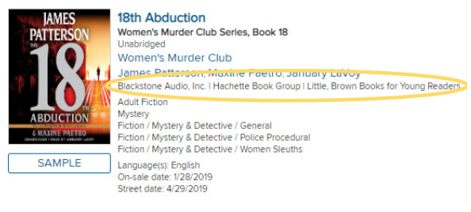

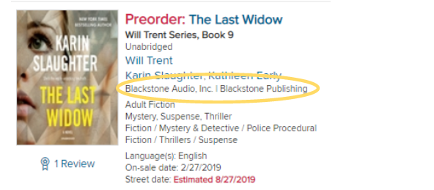
The first image shows a Blackstone “Partner” title: we believe this means another publisher (in this case, Little, Brown) owns the rights to both the print and the audio, and has contracted with Blackstone to offer audio formats.
The second image shows a Blackstone’s “Own” title: we believe this means that a print publisher owns the rights to print formats, and Blackstone alone owns the rights to audio formats.
At this time, the WDLC is boycotting both of the above examples, encompassing all of Blackstone’s eAudio products.
- I represent a tiny library. How can a boycott make a difference?
Since our goal is to communicate to Blackstone specifically and to publishers in general that we protest the embargo, each library’s voice is important, no matter how much they spend. The WDLC encourages active participation by libraries of all sizes.

